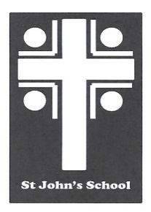
St John’s School Uniform Order Form – Grey Trousers St John’s School
Contact Name Date 6 Stuart Road
Student Name Ranfurly
Address Town Email: office@sjr.school.nz
Email
Phone Mobile

Uniform Order Details |  | Sizes Available – Enter Quantity Required
Product | Colour | 4  $40.00 | 6  $40.00 | 8  $40.00 | 10  $42.00 | 12  $42.00 | 14  $45.00 | 16  $45.00 | Price | Total
NA-CK1306 Trousers | Grey
Postage |  |  |  |  |  |  |  |  | $7.00 | $7.00

Delivery Details Payment Details Total:
All orders will be delivered to the school. |  | Payments to be given with the orders. Cheques made out to St John’s School Uniform Account or paid by internet to  03-0951-0045351-000. Please use name as a reference.

