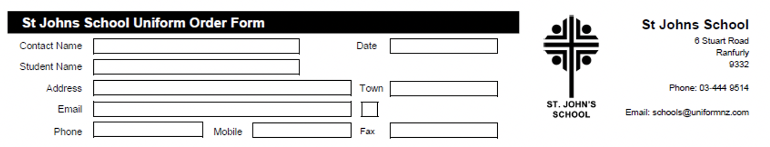
Uniform Order Details |  | SIZES AVAILABLE – Enter Quantity Required (grey highlighted – not available)
Product | Colour | 4 | 5 | 6 | 8 | 10 | 12 | 14 | 16 | Price | Total
Polo Shirt | Red |  |  |  |  |  |  |  |  | $30.00
1/2 Zip Fleece | Bottle Green |  |  |  |  |  |  |  |  | $40.00
School Short | Grey |  |  |  |  |  |  |  |  | $30.00
Tab Short | Grey |  |  |  |  |  |  |  |  | $45.00
Tartan Culotte | Navy/Green |  |  |  |  |  |  |  |  | $75.00
Postage |  |  |  |  |  |  |  |  |  | $7.00 | $7.00
TOTAL |  |  |  |  |  |  |  |  |  |  | $

All orders will be delivered to the school. Please allow approx. 14 days for delivery.
PAYMENTS: Payments to be given with the order.
Cash or internet banking. Internet banking to be paid to St John’s School Uniform Account 03-0951-0045351-000. Please use name as a reference. Thankyou.

Online Orders: http://stjohns.uniformnz.com

