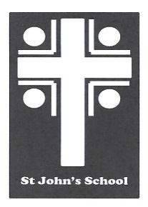
St John’s School Uniform Order Form – Jerseys St John’s School
Contact Name Date 6 Stuart Road
Student Name Ranfurly
Address Town Email: office@sjr.school.nz
Email
Phone Mobile

Uniform Order Details |  | Sizes Available – Enter Quantity Required
Product | Colour | 72cm  $84.00 | 77cm  $86.00 | 82cm  $86.00 | 87cm  $89.00 | 92cm  $89.00 | 97cm  $93.00 | 102cm  $93.00 | Price | Total
Merino ¼ zip jersey | Bottle
Postage |  |  |  |  |  |  |  |  | $7.00 | $7.00

Delivery Details Payment Details Total:
All orders will be delivered to the school. |  | Payments to be given with the orders. Cheques made out to St John’s School Uniform Account or paid by internet to  03-0951-0045351-000. Please use name as a reference. Thanks

