St John’s School Newsletter

School

6 Stuart Road
Ranfurly
03 4449514 (ph & fax)
office@sjr.school.nz
St John’s
School

Issue 5: 28th April 2023

Principal’s Page:

Nau Mai Haere Mai

Welcome Back
Welcome back for Term 2.
We welcome new students, Jade Aquino (Year 5) and Lochy Barnish (Year 0) and their families to St John’s School.
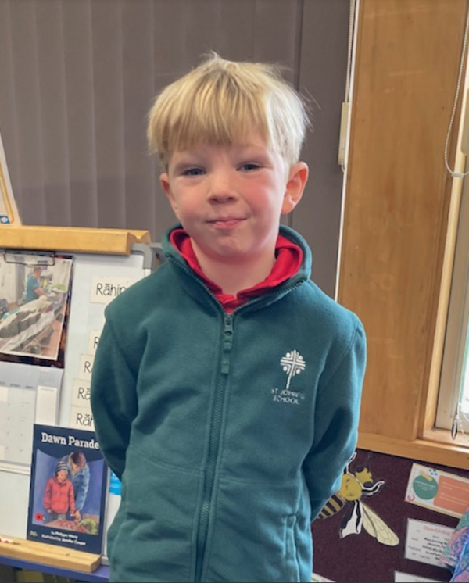
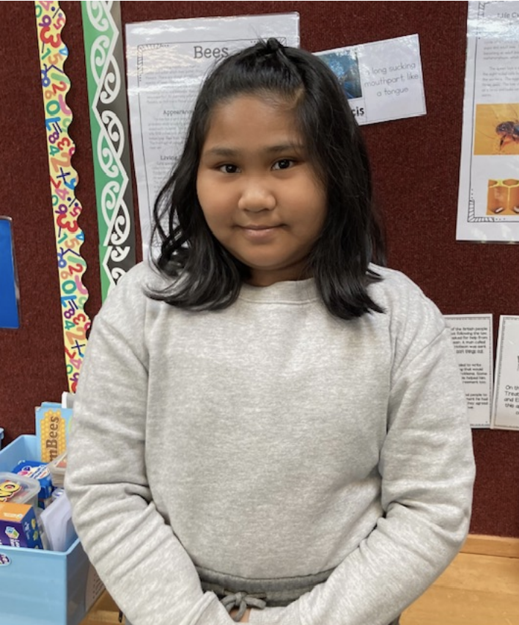

Covid
As there is a bit of Covid in our community again a reminder, please do not send children to school if they have a cold or sore throat, or are feeling unwell and please test for Covid.
If a child tests positive for Covid they need to stay at home for 7 days from when symptoms began.

Headlice
Please check your children’s hair regularly for this, as it is an ongoing issue. Please treat this when necessary.

Life Education Trust Mobile Classroom Visit
We have the Life Education Trust mobile classroom visiting our school on Wednesday 17th and Thursday 18th May.
Each class will have three visits to the classroom during the two days.
The Senior Class health lessons will be focusing on Wellbeing. The Middle Class, Brain/Food and the Junior Class Food/Body.

Pink Shirt Day
Friday 19th May is Pink Shirt Day.
Children can wear pink (or colourful) clothing to school on this day and bring along a gold coin donation as a fundraiser for the Mental Health Foundation.
Pink Shirt Day is celebrated throughout New Zealand and is a day where communities, schools, and workplaces promote kindness, inclusion and anti bullying and celebrate diversity - “Speak Up, Stand Together, Stop Bullying”.

Staff - Term 2
This term, Mrs Hazlett is on sabbatical leave so Mrs Erin Elworthy will be teaching Mrs Hazlett’s hours.

Bee Hives
The painting of the beehives has been completed.
Our next step is to sort out bee protective suits for children and adults. We received $2,400 from the Maniototo Lions Club to help out with the purchase of these and have some to try on so we can sort out appropriate sizes.
A big thank you to the Maniototo Lions Club for this very generous funding to help with this.

Special Character:

Altar Servers
Thank you to all those students in Years 4 - 8 who have been turning up on their rostered Sunday of altar serving or swapping if this doesn’t suit. Our parish really appreciates the job you do.

This week is the anniversary of the ordination of our Bishop - Bishop Michael Dooley.
Bishop Michael is the 7th Bishop of Dunedin and he was ordained Bishop on the 26th April, 2018.

This week we remember the sacrifices made by the ANZACs.
Our Faith Focus session on Wednesday focussed on this and we looked at why we have Anzac Day and how this is commemorated.

During the month of May we remember Mary, Jesus’s mother. We will be praying the Rosary each morning of May for prayer time, led by the Senior Class.

Junior Class News:

This term all the children in the Junior class will be learning a nursery rhyme or poem to recite at our school Poetry and Speech competition being held on Tuesday 23rd May at 9a.m. in our school hall.
We will sort these out next week and will send them home with the children for them to practice so they can recite by memory for this event. Please help them with these. Thank you.

This term Mrs Rachel Gray will be continuing with work on Ecosystems, with the focus on “Wool”.

Middle Class News:
Welcome back to Term 2!

We warmly welcome Jade into the Middle Room this term. Jade is a familiar face to our Year 5 students as she spent Years 1 and 2 with these children in the Junior Room before spending some time in the Philippines. Welcome back, Jade and family!

Sport
On the sporting front, we have Rippa Rugby coming up this term. This week, we have had Laura Sadler help teach the children the rippa rules and do some practice. Thank you to the parents who volunteered to coach or manage our teams for the Rippa Day in Alexandra. Please note the change of date - it is now Monday 22nd of May. We really appreciate the coaches giving up their time to come in and coach our teams during school. Thank you!

On the 15th of May, we have Berber coming to take the classes for a hockey coaching session. We look forward to this also.

Poetry and Speeches
Every two years the surrounding schools hold a Maniototo Speech Competition. This involves selected children from Year 3 to 8. This year it will be held in the Town Hall on the 1st of June.
The Year 3 children learn a poem and need to be able to recite it from memory to an audience. We will practice many poems at school and then they will choose one that I will send home for them to practice. We have a school recital, where a judge will choose the top 2 children to go through to the Maniototo Speech Competition.
The Year 4 and 5 children will write a speech at school on the topic of ‘Game Changers’. This will be written completely at school on an area of the topic of the students choosing. The speech will then be put onto cue cards, which the children will come home to practice with before the school recital. Two children from each age group will be chosen to compete at the Town Hall in the Maniototo Speech Competition.
Our school recital will be held on Tuesday 23rd May. Our Middle Room section will be between 9:15am and 11am.

Life Education Bus
Each year we are lucky to have Pip come with the Life Education bus to teach the children about an area of Health. This year our focus in the Middle Room is how our brain works and healthy food. Pip will be at St John’s on the 17th and 18th of May.

Reading and Writing
In Reading time this term the Year 4 and 5 students will be starting some Novel studies. They will read some of their novel with me in class and will be expected to read some for homework also.
Near the end of the term we will be reading some plays.
Our writing for the first part of the term will be our speech writing.

Maths
We are continuing to work on Addition and Subtraction strategies in the first half of the term. In Year 3 we are working on the children being able to work out larger equations in their heads and not relying on materials. The Year 4 and 5 children are working on using different strategies for solving harder addition and subtraction problems.

R.E
In Religious Education we are looking at the Holy Spirit strand and during the month of May we will be doing the Rosary led by the Senior Room each morning.

Key Dates:
15th May Berber Hockey coaching
17th/18th May Life Education Bus with Pip
19th May Pink Shirt Day - Wear bright mufti clothes
22nd May Rippa Tournament in Alexandra
23rd May School Poetry and Speech Recital
1st June Maniototo Speech Competition/Central Rippa Comp
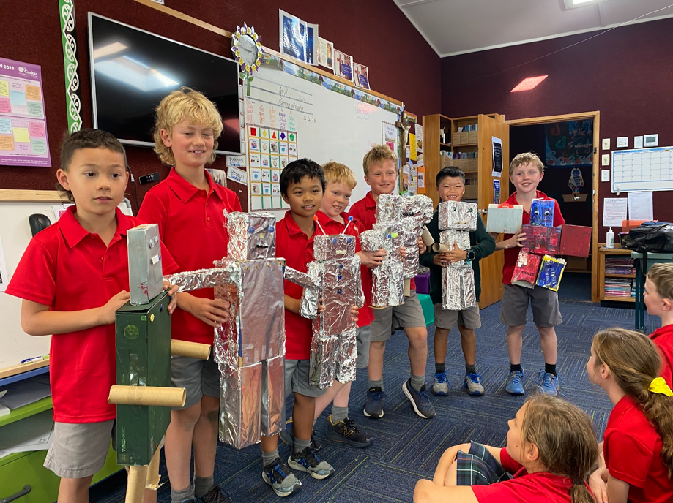
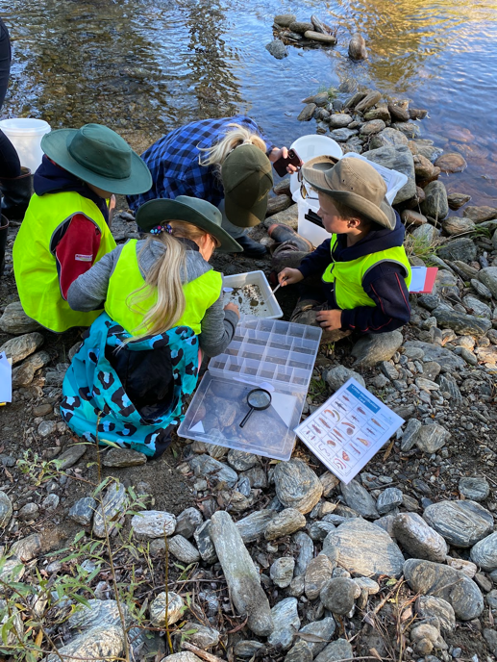
Robot making last term Stream Health day with Tiaki Maniototo

Ngā mihi,
Heather Dowling

Senior Class News:
If you have something kind to say about a person, tell them!

Welcome back for term 2 everyone. I am sure you enjoyed having your child at home over the holidays before we head into the busy winter term.

This week has been a somewhat muddly start for me as I have been away for two days at First Aid courses. Mrs Anna Jeffries has been in the classroom during my absence.

This term I have two focuses that we are working on, in line with our academic work.
- Developing base fitness
- Respectful behaviour.

The first will be done through work with our Year 8 Physical Activity Leaders and classroom activities. I am looking ahead to term 3 and the cross country, but in the short term, we have the rippa tournament coming up. The date for this is different to what had originally been indicated - details are below.

The second aspect is very important and one that does need development. Respect means that you accept somebody for who they are, even when they are different from you or you don’t agree with them. It helps build feelings of trust, safety and well-being. Teaching the children about respect in all situations they encounter is crucial and now are the years when children are so receptive to positive feedback so that they can effect a change if it is needed in their attitude, manner of speaking to others, nonverbal communication and general kindness. I am continuing our Resilience topic into term 2 and it will tie in with our learning with Pip and Harold through the Life Education Bus. We will be looking at managing our emotions in different situations.

Rippa (repeat of what was in the last newsletter with the date change included)
This event is happening on Monday 22nd May. If there is a change to your child's availability or your ability to help with transport, please let us know asap. The messenger page has been set up with the coaches and they will regularly come to school to prepare the teams for the tournament.
Laura Sadler from Otago Rugby Union came to school yesterday to take a rippa skills session also.

The children that are not attending the rippa tournament will attend school as normal.

 | Year 3/4 | Year 5/6 | Year 7/8
Coaches | Luke D | Wayne  Logan | Ryan  Gerard
Managers | Sharon  Jason | Gabby | Cate  Marcus
Players | Zach, Ben, Charlie, Theo, Caleb, Eli, Victor, Juliette, Millie, Maggie, Jack. | Jessie, Kaylah, Isla, Florence, Xavier, Joshua, Marcus, Finn, Harry, Harry, McKinley, Jae, Ethan. | Marley, Josie, McKenna, George, Logan, Karl, Hayley, Eddie, Mac, Jacob.

Homework
Our routine continues as it was in term 1, with one small addition. To help develop the ability to speak clearly and confidently in front of others, each week your child is to find out an interesting fact, a piece of information, a news item or even a new word. They will tell other classmates about this on Friday.
Help them out at home by guiding them to find something to share and then have them practice how they will share this with you. We will be practicing speaking clearly and in an interesting manner, and making eye contact.
They need to be familiar with what they are sharing so that they do not need to read it from the paper they have recorded it on. I expect to see this recorded in their homework book as they then won’t misplace it.
I have glued a note into their homework book reminding them of this. Homework starts in week 2.

The reason we are doing this is that we are working towards our speech presentation day on Tuesday 23rd May. At this, each child shares the speech that they have written at school. Our topic this year is ‘Game Changers’ a person, or event or an invention. Please chat with your child about this topic, but let them write their own speech at school. I know it's tempting to help with the writing but trust your child, they will all create great speeches.

Mathletics
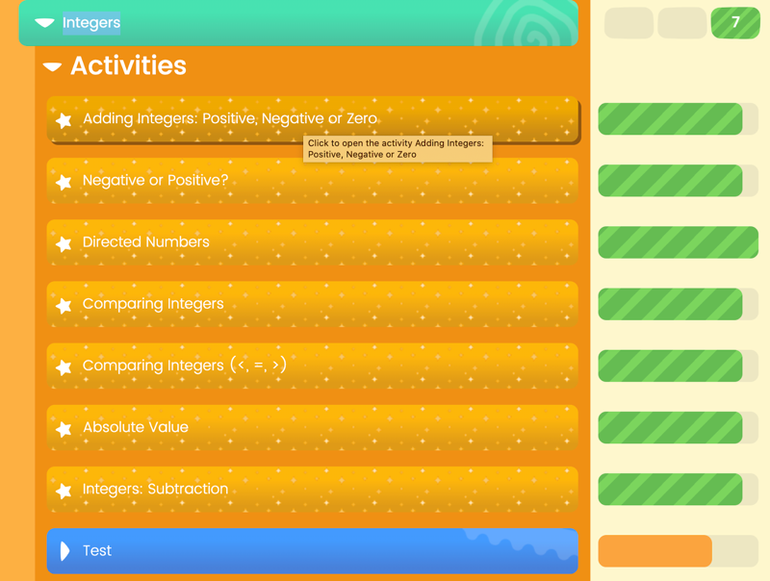

The children are ticking along well with their Mathletic work and most children reach their goal each week. The weekly goal is to get 1000 points and most of the children will need your support to do this. Although we get some points at school, they will need to get some at home too.
You may have heard your child talk about getting ‘Green Bars’, so they can then earn extra money in Banqer. This means that in a topic, they get all the activities to the green colour (this does not include the pretest or posttest).
This is an example of a topic showing the activities completed to Green Bar level, which basically means getting 9/10 or 10/10 on the questions.

Kind regards (mihi aroha)
Geraldine Duncan.

Senior Room Motto 2023

Before ….
We speak - we listen
We quit - we try
We do - we think
We react - we breathe.

Board of Trustees:

Our next meeting is Tuesday 9th May at 7p.m.

Notices and Dates:

Term 2  Week 1 | Sunday 30th April | Sunday Mass at 4pm  Altar Servers: Sam & Arthur Elworthy
Week 2 | Sunday 7th May | Sunday Mass at 4pm  Altar Servers: Jacob Sutherland & Florence Dowling
Week 3 | Sunday 14th May | Sunday Mass at 4pm  Altar Servers: Mac, Finn & Charlie Dowling
Week 4 | Wednesday 17th & Thursday 18th May | Life Education Trust Mobile Classroom
 | Friday 19th May | Pink Shirt Day
 | Sunday 21st May | Sunday Mass at 4pm  Altar Servers: Zach Tomalon & Harry Dowling
Week 5 | Monday 22nd May | Rippa Rugby Tournament  – Yr 3 - 8
 | Tuesday 23rd May | St John’s School Speech/Poetry Competition
 | Sunday 28th May | Sunday Mass at 4pm  Altar Servers: Ethan Chisholm & Josie Herlihy
Week 6 | Thursday 1st June | Maniototo Speech Competiton  - Yr 3 - 8
 | Sunday 4th June | Sunday Mass at 4pm  Altar Servers: Logan & Mckenna Suddaby
Week 7 | Sunday 11th June | Sunday Mass at 4pm  Altar Servers: George & Theo Dowling
Week 8 | Sunday 18th June | Sunday Mass at 4pm  Altar Servers: Cyrus Janerol & Keisha Evangelista
Week 9 | Sunday 25th June | Sunday Mass at 4pm  Altar Servers: Ben Scott & McKinley Francis
Week 10 | Sunday 2nd July | Sunday Mass at 4pm  Altar Servers: Axel & Kaylah McAuley

CARDRONA / TREBLE LOCAL SCHOOL CHILD SEASON PASS 2023

Our local school seasons passes are available to purchase online by following the link - https://secure.cardrona-treblecone.com/s/local-school-child-season-pass/p/local-school-child-season-pass-2023

YEAR 1- 8 $155 YEAR 9 – 13 $225

We hope to see some of your students out there this season!

Kind regards,

Julia Manthorpe​​​​

Reservations & Guest Services Supervisor
0800 440 800

