St John’s School Newsletter

School

6 Stuart Road
Ranfurly
03 4449514 (ph & fax)
office@sjr.school.nz
St John’s
School

Issue 1: 3rd February 2023

Principal’s Page:

Welcome
Welcome back to everyone for 2023. We hope you all enjoyed a restful, relaxing holiday.
We welcome some new students and families to our school:
Karl Suplente Year 7
Marcus Carig Year 5
Victor Suazo Year 4
Mack Mayo Year 2
Bjorn Ball Year 1
George Love Year 0

Staff 2023
Our staff remains the same as last year with Mrs Geraldine Duncan teaching Years 6,7 and 8 with Mrs Rachel Gray releasing her on a Thursday morning until morning tea time.
I continue to teach the Junior Class; Years 0, 1 and 2. Mrs Rachel Gray releases me all day on a Wednesday and also on a Thursday afternoon.
Mrs Heather Dowling continues to teach the Middle Class; Years 3, 4 and 5. Mrs Rachel Gray will be releasing Heather on a Thursday morning from 11a.m - 12.30p.m.
Mrs Jayne Hazlett will continue to work three mornings (Monday, Tuesday and Wednesday) with groups and individuals in the area of literacy. Literacy includes reading, reading comprehension, writing, spelling and alphabet activities. Teachers have identified children and groups of children with particular needs to work with Jayne.
Sharon Thompson will be working as Teacher Aide in the Senior Class 4 mornings a week with Becky Bruhns as Teacher Aide in the Middle Class 4 mornings a week.

Waitangi Day
School is closed on Monday 6th February for Waitangi Day.

Stationery
Children have been issued with new exercise books and a stationery account.
These accounts include Mathletics (an online maths programme that supports the class programme) for the Middle and Senior class students.
Exercise books can be covered as this protects them from many things, but this is not a requirement. If you would like to cover your childrens’ books please ask them to bring the books home one night to do this. Thank you.

Stationery money is to be paid by Friday 24th February, please.
Internet banking can be made to the following account number: 03 0951 0066195 00
Please remember when paying by internet, to put your name and “School Stationery” as a reference. Thank you.
Swimming
We have booked a swim week for the whole school with a private swimming tutor, Jo Blackie for Week 3: 13 - 17 February.

Each class has 1 or 2 weekly pool sessions for Weeks 1 and 2 and individual teachers will let you know these days and times.
We will be working out ability grouping during these swim sessions for our Swim Week.

A reminder that children need to bring their swimming gear in a bag of some sort that is easy to carry to swimming. Thank you.

Telephone
A reminder, please, that when ringing the school cellphone or landline, do not leave a message after 1.15p.m. as teachers are in their classrooms teaching and there is not always someone in the office to clear messages until after school. The cellphone is also difficult for teachers to access and hear, in class time.
If your child/children are going to be absent from school, please ensure that the classroom teacher is aware of this by texting the school cellphone or ringing the school before 8.30a.m. Thank you.

Pie Warmer/Microwave/Sandwich Press
We have a pie warmer available for children to heat pies, savouries etc. We also have a microwave children can use to heat basic food items at lunchtimes. The Middle and Senior Class have a sandwich press they can use to toast sandwiches at lunchtime.

Maniototo A & P Show
The Maniototo A & P Show is being held on Wednesday 15th February.
There will be no swimming lessons on this day.
Children will be dismissed from school at 12.30p.m. on this day to enable them to attend the show with their parents.
Buses will collect any bus students from school at approximately 12.30p.m.
If you are unable to collect your child from school on this day and need them to come home on the bus please let the classroom teacher know. Thank you.

Up to date contact details
Attached to the paper newsletter is a form for parents to fill in to enable us to update our files. Please fill in one for your family and return it to school asap.
If your contact details and emergency details have not changed, you do not need to do this.
Office Hours
A reminder that Fiona Weir’s office hours are:
Monday 9 - 1p.m. Thursday 9 - 3p.m. Friday 9 - 12p.m.
If you have uniform enquiries it is preferable that you contact Fiona about this during her hours or email her at: office@sjr.school.nz

Emailing newsletter
Our newsletters are emailed to those families who have provided us with an email address. If you don’t receive your newsletter by email please contact Fiona Weir at: office@sjr.school.nz
Our newsletter comes out every three weeks so you should receive a newsletter in weeks 1, 4, 7 and 10. For anything else that comes up, eg swim week, there will be a separate newsletter.
Remember to also check our website:
www.sjr.school.nz

Scholastic Lucky Books
Please remember if you are ordering Scholastic Lucky Books for your children as presents and do not want them to see these, just write a note on the order or let us know and you will be texted when the books arrive.

School Uniforms
The start of each term is the time when we order school uniform items. If you wish to order outside of these times, you will be asked to pay full postage in the total cost. If you are needing a uniform order form, you can print one off the school website under the “Notices” tab - then “Class Notices”
You can also order yourself, online at:
http://stjohns.uniformz.com

School Uniform
A reminder that children are to dress in correct uniform please:
Boys - Summer
Red polo shirt
Grey shorts
School polar fleece or jersey
Grey socks
Brown/black shoes or sandals
Girls - Summer
Red polo shirt
Skort
School polar fleece or jersey
Black socks
Brown/black shoes or sandals
We ask that children who have long hair, have this tied up with brown, red, green, black or white hair ties.

School Buses
Each year we are asked by the Ministry of Education transport advisor to reiterate to parents and caregivers the following points:
- It is the responsibility of the caregivers to get bus children to pick up locations and to collect them from drop off locations
- It is recommended caregivers and children arrive at the bus stop locations at least 5 minutes prior to the time advised by the bus provider
- Caregivers should stay with their children while they are waiting for their school transport in the morning and meet them in the afternoon as they get off the bus
This year we are introducing a “Bus Transport Code of Conduct”.
Each bus student will receive one of these forms which are to be read, discussed and signed by both the student and parents, then returned to school. Thank you.

Head Lice
A reminder to check your children’s hair regularly for this and treat if necessary. Thank you.

Parent Information Evening
On Tuesday 21st February we will be holding a parent information evening. You can attend all sessions or as many as interest you.
The presentation explains the expectations and programmes in each class.
Junior Class 7 - 7.20p.m.
Middle Class 7.30 - 7.50p.m.
Senior Class 8 - 8.20p.m.
We look forward to seeing you there.

Covid 19
A reminder that if you have Covid you must self-isolate for 7 days. Day 0 is the day your symptoms started.
Please ensure children stay at home if they are unwell, or starting to develop a cold or sore throat or other Covid symptoms.
Thank you.

Ko nga pae tawhiti
Whaia kia tata
Ko nga pae tata
Whakamaua kia tina
The potential for tomorrow depends on what we do today

Special Character:

Next Monday the 6th February we have a public holiday to remember and commemorate Waitangi Day.
We commemorate the signing of the Treaty of Waitangi on this day in 1840. Waitangi Day was first commemorated in 1934. The Treaty is often called “The Founding Document” of New Zealand. It is an agreement and exchange of promises made between representatives of the British crown and representatives of Maori.

Junior Class News:

*We begin 2023 with 15 children in the Junior Class. We welcome three new students to our class: George Love, Mack Mayo, Bjorn Ball.

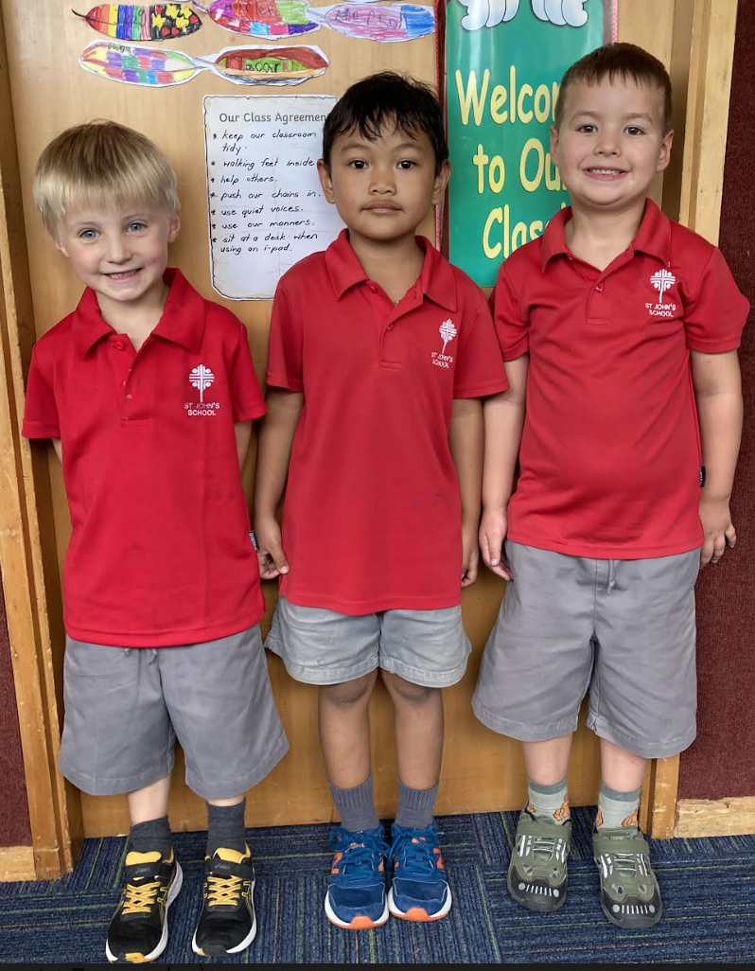

*All Junior Class children should have brought home a letter about homework expectations for the year. Also a stationery account and a request for reading helpers for Terms 1 and 2. If you can help with reading please fill in the form and return it to school asap, if you haven’t already done so.

*Swimming for the Junior Class is on Tuesday 7th February 1.15 - 2p.m. Children need to bring their swimming togs, towel, goggles etc in a bag please. The following week is our swim week and children will be swimming in their ability group each day (details will be given to parents next week re grouping and timetable).
The following week there is no swimming as Maniototo Area School have their swim week.

*Our theme for this term is “Bees”. Mrs Rachel Gray will be taking the children for this theme during my release time. Anna Pettigrew (Flynn’s Mum) has very kindly given the school 12 beehive boxes. The first job is to paint these, which Mrs Gray will work on with each class. Eventually they will be set up in our “Holy Paddocks” area and we will learn about how to look after bees and get them to produce honey (all with the help of Anna). We will be looking at purchasing some bee suits for children and teachers to enable them to interact safely around the beehive area.
A big thank you to Anna for the donation of the hives and for her willingness to help us out with this project.

*Junior Class children will be working on artwork over the next two weeks, for the A & P Show. The theme is “The Sky’s the Limit” so there is a lot of opportunity for imaginations to run wild!

Middle Class News:
Wow! What a fantastic start to the term we have had!
I feel very lucky to be teaching the children in the Middle Class.
We warmly welcome Victor Suazo, Marcus Carig and their families who have joined us this year.
You will have all read the letter I sent home earlier in the week with all the information about what is happening over the coming weeks. I will talk about our weekly programme and expectations in more detail at the parent information evening on the 21st of February.
This week we have made our own class treaty, written about our holiday memories, started our show art, practised the reading and maths activities and we’ve started doing an ‘All About Me’ poster.
Once again, please don’t hesitate to contact me via the school cellphone or email if you have any questions.

Nga mihi,
Heather Dowling

Senior Class News:
Greetings everyone

Just a short message this week as you will have received the lengthy start of year letter on Wednesday.

What I really want to share with you is what a positive start we had to the school year on Wednesday. I was somewhat nervous (as I am every year) about meeting my class of ‘23 but when the end of day came, I was feeling very happy and excited for our year ahead. It’s going to be a good one.

One amendment to my newsletter. We are now swimming on Tuesday AND Friday next week. Please send your child along with togs and a towel and they can wear a rash vest if they wish. Googles are a good idea as the pool water is chlorinated and I did suggest to the kids if they had spare goggles, they might like to share them for the session.

I look forward to seeing you all at the parent meeting in week 4.

Kind regards

Geraldine Duncan

Board of Trustees:

Our first meeting for 2023 is on Tuesday 14th February at 7.30p.m.

Notices and Dates:

Term 1 2023  Week 1 | Sunday 5th February | Sunday Mass at 5pm  Altar Servers: Logan & Mckenna Suddaby
Week 2 | Monday 6th February | Waitangi Day – School Closed
 | Sunday 12th February | Sunday Mass at 5pm  Altar Servers: George & Theo Dowling
Week 3 | Tuesday 14th February | BOT meeting
 | Wednesday 15th February | Maniototo A & P Show
 | Sunday 19th February | Sunday Mass at 5pm  Altar Servers: Cyrus Janerol & Keisha Evangelista
Week 4 | Sunday 26th February | Sunday Mass at 5pm  Altar Servers: Ben Scott & McKinley Francis

