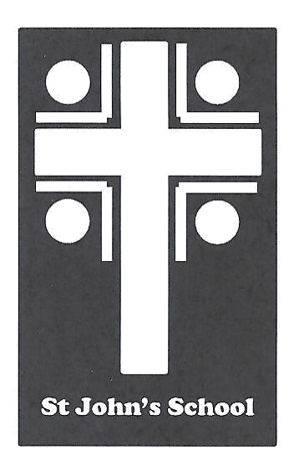
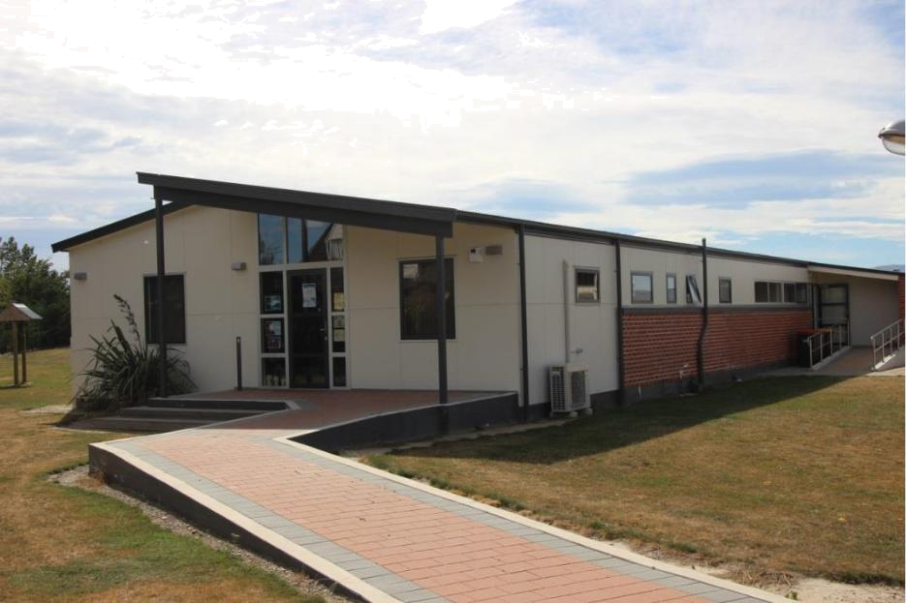

St John’s School

Ranfurly

Information Booklet

2022

1
At St John’s School we provide:

- A professional, dedicated and caring staff

- A wide variety of programmes which cater for our students’ needs

- An open door policy which encourages community involvement

- A positive, caring learning environment


This booklet is designed to give you some information about the procedures followed at St John’s School. If you wish further information, please contact the school office.

2
Table of Contents

Introduction & Contacts……………………………………………… | 4
Members of Staff & Board of Trustees …………………………… | 5
Terms and Holidays 2021& Absences …………………………… | 6
Accounts, Appointments with a Teacher & Attendance Dues … | 7
Behaviour Management Plan, Car Park/Parking & Class Rules | 8
Cyber Safety ……………………………………………………………... | 9/10
Cyclists …………………………………………………………………… | 10
Diseases & Dental Treatment ………………………………………… | 11
Emergency Closing ……………………………………………………. | 12
Enrolments ……………………………………………………………… | 12/13
Fire/Evacuation Procedures & First Aid Treatment …………… | 13
Grounds & Head Lice ………………………………………………… | 14
Home Learning ………………………………………………………… | 15-17
Injuries, Lost Property & Lunches ………………………………… | 18
Medication, Mufti Days & Newsletters …………………………… | 19
Parent Help & Parent Teacher Association ……………………… | 20/21
Painting Shirts & Pedestrians ……………………………………… | 21
Phoning School & Religious Education …………………………… | 22
Reporting to Parents, Road Safety & Skateboard/Rollerblades | 23
School Costs …………………………………………………………….. | 24
School Buses ……………………………………………………………. | 24/25
School Hours, School Mass & Sports ……………………………… | 26/27
Sports Uniforms & Staff Meetings ………………………………… | 27
Stationery Purchases, Transport & Uniforms …………………… | 28/29
Visitors …………………………………………………………………… | 29

3
Introduction

Welcome to St John’s School Community

St John’s School is a 3 teacher, Catholic, integrated school which educates children from Year One (5 years of age) to Year Eight.

St John’s School is a school with special character. It offers a Catholic education. Our school provides a supportive, caring, “family” environment where all children are valued and encouraged to challenge themselves in a supportive atmosphere.

The emphasis on Gospel values within the school has a positive influence on children’s behaviour and progress.

Class, group and individual teaching and school-wide activities are used to address the learning needs of all students and utilise teacher strengths.

The school is set in park like grounds, providing an ideal environment for Education Outside the Classroom, as well as providing a stimulating, free play area for children to use during breaks. The school has three well maintained classrooms, a Principal’s office, administration office and a staff room. The school offers a multi purpose all weather turf, a full sized rugby field, adventure playground, sandpit, a wooden play area, ample grassed areas, and an inventive playground for outside activities. For wet weather activities, the school has access to the parish hall which also houses the library.

The board, staff and P.T.A work co-operatively to provide a positive working environment which enhances student achievement.

Contacts
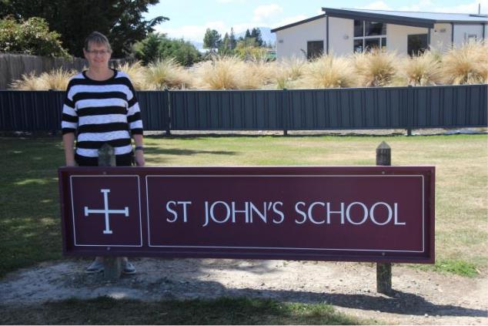

Principal – Mrs Susan Mulholland principal@sjr.school.nz

School Phone Number 03 4449514 School Mobile Number 0272661758

School Office Email – office@sjr.school.nz

Education Review Office – www.ero.govt.nz

4
Members of Staff

Teachers

- Y1-2 Mrs Susan Mulholland (Mon, Tues, Thurs till 12.30pm, Friday), Mrs Rachel Heaney (Wed & Thurs from 1.15pm),
- Y3-5 Μiss Rachel Heaney

- Y6-8 Mrs Geraldine Duncan

Principal Release Teachers

Specialist Teacher

Rachel Heaney

Jayne Hazlett

School Administrator
Mrs Fiona Weir

School Cleaner

Mrs Dolina Keenan

Caretaker

Mr Mike Summers

Parish Priest and School Chaplain

Fr Gerard Aynsley, Fr Sani

Board of Trustees

A Board of Trustees governs the school.

Chairperson

Ryan Dowling

Principal

Susan Mulholland

Treasurer

Kym Smith

Minute Secretary

Cate Herlihy

Staff Representative

Geraldine Duncan

Parent Representatives Proprietor’s Representatives

Logan Dowling
Fr Sani Lam,
Debbie Dowling

5

Terms and Holidays for 2022

Term 1: Tuesday 1st February – Thursday 14th April

Term 2: Monday 2nd May – Friday 8th July

Term 3: Monday 25th July – Friday 30th September

Term 4: Monday 17th October – Wednesday 14th December (approx.)

Absences

If your child is sick, has an injury or is really tired, please keep them at home until they have recovered. On other occasions, please be aware of the following legislation.

The Education Act 1989, requires all students aged between 6 and 16 to enrol at and attend school whenever it is open. Children are excused from attending school due to sickness or bereavement.

Every Board of Trustees must take all responsible steps to ensure that students who are required to attend school whenever it is open, do so.

Teachers mark an attendance register. If a pattern of absences is noticed or if a child is absent for more than 15% in one term, our concern will be referred to the parents and the Ministry of Education.

Section 25B of the Education Amendment Act No 4 1991, allows for the principal to release a pupil from attendance at school if he/she is satisfied that the student will receive outside the school tuition acceptable to the principal and at a time agreed to by the parents and the school. Please contact the principal for permission if you wish to enrol your child in regular tuition during school hours.

Please phone to let us know if your child is not attending school by 8.45am. We check all absences to ensure student safety.
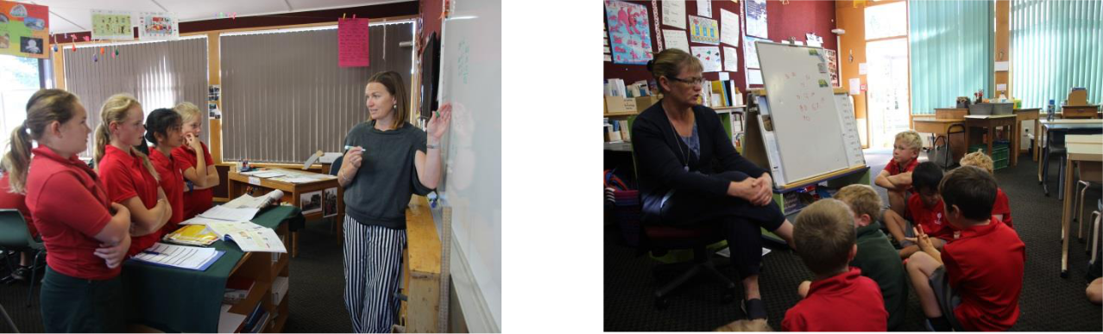

6
Accounts

An account for any stationery purchases, school trip e.g. ski trip is requested with the amount and date it is required to be paid by. Money can be paid by either sending money back with your child (cash/cheque) or by internet banking into the school bank account: Westpac 03 0951 0066195 000. Please add what the money is for in the particulars box, your child’s/children’s name in the reference box.

Appointments with a teacher

If you wish to talk to your child’s teacher, please talk to the teacher and arrange a time to see them. Phone the school office to make an appointment.

Attendance Dues

Our Catholic Schools were integrated into the state system after a lengthy negotiation with the government. It resulted in the passing of the Private Schools Conditional Integration Act in 1975. This Act created a partnership between the State and the Catholic Church, integrating private schools into the state system in such a way that allowed the “Special Character” of our Catholic Schools to be preserved and safeguarded. Part of the agreement for integration was that the buildings of our schools had to be upgraded to meet a certain standard. To do this, the Catholic Bishops of New Zealand had to borrow millions of dollars from the government and also from other sources. Today, many years later, a significant debt is still owed, and the repayment of the loan is done through the collection of “Attendance Dues”. The Act allows for the collection of costs associated with the provision of school, land and buildings. By law, “Attendance Dues” cannot be used for any other purpose.

Attendance Dues are set at $450.00 per year, inclusive of GST, per pupil.

The fees are collected by the Dunedin Diocese. You will receive an invoice from the Diocese directly. This money does not come directly to the school. You can arrange with the Diocese office your own way of paying this and support is available if you find hardship in paying this invoice. Please approach Fr Gerard Aynsley if you have any concerns with this requirement.

7
Behaviour Management Plan

The Mission of St John’s School Ranfurly calls us to demonstrate Gospel values in a caring, Catholic community where everyone is challenged to engage in learning, act with integrity, use initiative and achieve excellence.

Our Behaviour Management Plan is based on RESPECT.

- Respect for ourselves

- Respect for others

- Respect for property. Every person who enters our school has the right to enjoy a safe and secure environment

- Every student has the right to learn in a class without disruption

- Every teacher has the right to enjoy their teaching without disruption or disobedience

Car Park / Carparking

- Children would enter a vehicle from the footpath side door if possible

- Parents should park in the school car park or on the school side of the road or in the parish grounds

- Children must walk down the path beside the car park

- Children should not be on the road or playing around vehicles

- Please do not park on the bus stop

- Illegal and dangerous driving behaviours will be forwarded to the Police Officer

Class Rules

Your child’s teacher will be happy to inform you of the class rules in place. These are usually prominently displayed in the room.

Class rules are revised from time to time, and the children themselves have input into them.

8
Cyber Safety (ICT- Information Communication Technology)

The school’s computer network, Internet access facilities, computers and other school ICT equipment/devices bring great benefits to the teaching and learning programmes at St John’s School and to the effective operation of the school. Our school has rigorous cyber safety practices in place, which include cyber safety use agreements for all school staff and students. The overall goal of the school in this matter is to create and maintain a cyber safety culture which is in keeping with the values of the school, and legislative and professional obligations. This use agreement includes information about your obligations, responsibilities, and the nature of possible consequences associated with cyber safety breaches which undermine the safety of the school environment. All students will be issued with a use agreement and once signed consent has been returned to school, students will be able to use the school ICT equipment/devices. The school’s computer network, Internet access facilities, computers and other school ICT equipment/devices are for educational purposes appropriate to the school environment. This applies whether the ICT equipment is owned or leased either partially or wholly by the school, and used on or off the school site.

The school may monitor traffic and material sent and received using the school’s ICT network. The school may use filtering and/or monitoring software to restrict access to certain sites and data.

The school may audit its computer network, Internet access facilities, computers and other school ICT equipment/devices or commission an independent forensic audit.

Rules to help keep St John’s School Students Cybersafe These rules will help us to stay safe when using ICT at school

- I understand that school computers are to help me with classroom learning.

o It is important to keep safe while using the Internet and e-mail. This means I must follow the school’s safety rules.

- The only time I can use the Internet and email at school is:

  - After I have signed this agreement.

  - When a teacher is present.

- I am not allowed to try and look up things on the Internet which I know are not for children. Some of it is against the law. (Your teacher will explain it to you).

- I must be sensible when using email. I will not send messages which I would not want my parents or teacher to read.

o I will not damage any equipment or furniture.

o I will report any damage to my teacher straight away.
- I will not use any school computer for downloading or personal games.

9
- I will not print anything without the permission of the teacher.

o I will share the equipment.

- I will not deliberately disrupt the computer or the school’s

network.

o I will not be involved in electronic vandalism, like viruses.

- I will not give anyone on the Internet information about myself or others – this includes addresses and phone numbers.

- I will tell the teacher if I come across any problem.

Cyclists

- NZ Police, Bike Wise and the LTSA recommend that cyclists should be a minimum of 9 years old if unaccompanied

- An Australian/New Zealand standards cycle helmet must be worn at all times (providing it has been well maintained and pertains to the required standards)

- The helmet must be adjusted correctly and securely fastened

- Children should wear school safety vests

- All bicycles must be walked in/out of the school grounds

- Bikes are not to be ridden on school grounds until after 3.15pm

- Bikes must be stored in the bike rack

- Parents/caregivers and children are responsible for maintaining the bike in accordance with the current NZ bike code

- Parents must ensure that if their child/children are biking to/from school alone, they understand road rules, are aware of traffic and are familiar with the route from their home to school

- The Principal has the right to revoke the privilege of cycling to and from school if deemed necessary

Road safety skills and procedures are a lifetime necessity, which we at St John’s School can help to establish firmly at an early age, for the present and future benefit of our children and the community.

10
Diseases

Common Diseases

Here are a few guidelines. It is the responsibility of the parent or the doctor to decide whether a child should attend school or not. We would rather a child stay at home until 100% fit for school, than come back feeling miserable, particularly with some of the viruses that affect children during the winter.

Infectious Diseases

For measles, whooping cough, chicken pox etc, - get your doctor’s opinion. If you are at all unsure or worried about your child’s health – contact your doctor. With Impetigo sores, ringworm, head lice etc, a general rule would be that the child need not stay away provided that he/she is receiving appropriate medication and the infection is covered.

Children should not attend school if they have any of the following symptoms:

- very runny nose and can’t keep them clean

- high temperatures

- any communicable type illness

- severe coughs, sore throats, weepy or sore eyes, or sore ears

- if a child has vomited during the past 24 hours

- an unidentified rash

- tummy pains and / or diarrhoea

The aim is to help protect other children, families and staff. If a child becomes unwell at school, you will be contacted. Staff will always act in the best interest of the child.

Dental Treatment

The Dental Bus will visit Ranfurly every February, and check all children’s teeth. If your child requires a follow up, you will be contacted by the Dental Bus Dental Nurses.

For Dental Emergencies you can ring Alexandra School Dental Nurse on 027 284 9857 or contact a dentist of your choice.

11
Emergency Closing

This is not a common occurrence, and most likely to happen during the winter when the school buses cannot travel on the roads.

If buses have to leave school early due to deteriorating road conditions e.g. snow, a decision will be made by the Bus Controller for the area. You will be notified on any decision. Should we be unable to contact the parents or the emergency contacts on our data base, the children concerned will be supervised at school until such time as suitable arrangements can be made.

Enrolments

As a Catholic school, we provide an education to Catholic children or to those whose parents choose a Catholic education for their children.

Initially please contact the Principal, who will then refer you to the Parish Priest who must sign a Preference/Non Preference Form for your child before he/she can be enrolled. We can only enrol 4 extra non preference pupils or families who have no Catholic connection whatsoever.

You will be asked to pay Attendance Dues to the Diocese of Dunedin. See Attendance Dues section. By enrolling your child at St John’s School, it is understood that you agree to him/her taking part in all aspects of Religious Instruction and that he/she will wear the school uniform as decided by the PTA, in consultation with the parents.

Prior to their first day of school, it is requirement that we must have:

- an enrolment form

- signed preference form

- copy of Immunisation Certificate

- copy of a Birth Certificate

Children are entitled to start school the day of their fifth birthday. It is recommended that your child has familiarization visits prior to starting school.

Stationery for pupils will be supplied by the school. An account will be sent home when the stationery is issued.

If you are enrolling your child from another school, it is helpful to bring along a report from the last school and any books your child has.

12
Preparing your child for school

Children settle quickly into school life if they have a few skills:

- Can they recognise and write their name?

- Can they name shapes and colours?

- Can they count to and from 10?

- Can they dress themselves after swimming lessons?

- Do they know how to unwrap and eat their lunch?

- Do they know the safest way to walk to and from school?

- Do they know how to travel on the school bus?

Please talk to your child. When they arrive at school they are expected to follow instructions.

Read to your child, a love of books is first learnt at home.

Fire/Evacuation Procedures

Instructions for fire and / or evacuation.

Signal: A continuous ringing of the school bell or alarm

- Walk quickly out of the building using the door or classroom fire door

- Assemble under the far goalpost toward Ranfurly township

- Checks: Girls and Boys Toilet Area, Staffroom, Office Area, Hall and ESOL Room

- Teachers use their attendance registers to immediately account for all pupils

- Once out, stay out – Do not return to the school buildings

First Aid Treatment

From time to time accidents do occur in spite of careful supervision. Most problems are minor and are remedied by a quick visit to the First Aid Cabinet. This is when we need to know of any allergies your child might have (bee stings, sticking plaster etc). In the unlikely event of a more serious accident, immediate first aid will be given and the parents contacted. Should the parents not be immediately available, the school will continue with the necessary steps. We realise that you are not always available so it is important we have emergency numbers of a close friend or relative who could look after a child until you can be contacted.

13
Grounds

The school takes no responsibility for children using the grounds after school hours. Children may play in the grounds after school and in the weekends but the following rules must be obeyed:

- After school, all children must leave the grounds by 3.15pm and must report home before they return. Teachers are not responsible for the supervision of children before 8.30am or after 3.15pm.

- Dogs and smoking are not permitted in the school grounds.
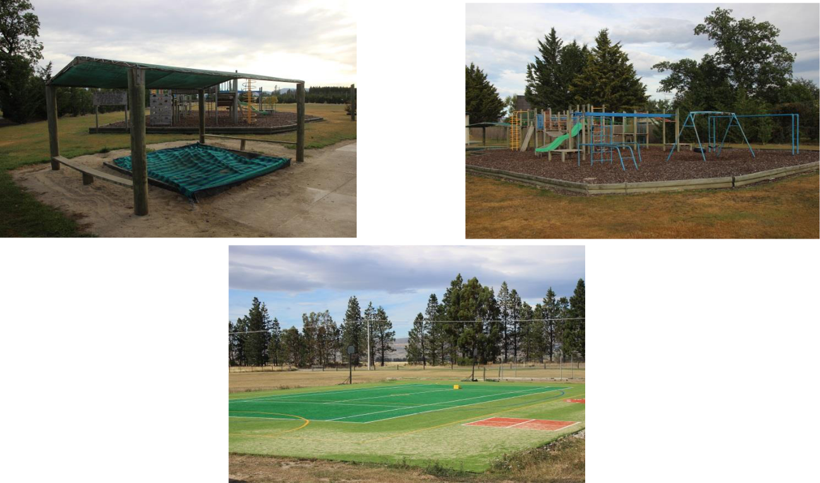

Head Lice

Please check your children’s hair regularly for head lice and treat with preparations available from a pharmacy.

You can contact the Public Health Nurse at 03 4449424 for more information. Please let us know if your child catches head lice – so that we can remind everyone to check children’s hair. This is in confidence, but may help us find the cause of infestation.

14
Home Learning

Primary children should not be burdened with large amounts of school work to be done in what should be leisure time. However, the discipline of having to attend to some routine of learning activity or research work is of value to all children. Homework is set at the beginning of each week and involves reading, spelling and maths.

Years 0-2

Junior Class: This takes the form of sharing their daily reading with parents. Please make this an enjoyable time, talk about the story with your child. If your child is having difficulty or has chosen a library book to share with you, please read it to them. In the later part of Year One, children will be expected to spend some time learning spelling words and also practicing skip-counting in 2’s, which leads to them learning their 2x tables and beyond. A child is not expected to spend more than 20 minutes a night on homework.

Years 3-5

Middle Class: Children are expected to read every night. The homework sheet will usually have reading, spelling and tables. Support your child by talking about their reading and help them to learn spelling and basic facts. This will reinforce that these learning skills are important while also developing the home and school partnership.

Years 6-8

Senior Class: Home learning is outlined in their homework book and builds upon school learning. Your child will need your support and encouragement with this, but you will find it is not too onerous.

Here are a few guidelines for helping your child with home learning. Please provide a place where your child can work without interruption from siblings. In front of the television is not a good idea, in spite of what they may tell you! Your child should be able to complete most of the work by themselves, however they may occasionally ask for help or guidance and need access to reference material like a dictionary, an atlas, or the internet.

Your child will really appreciate it if you take an interest in their work. But remember it is your child’s homework. For some classes you are asked to sign your child’s book each day. Before doing this please remember that the school’s expectation is that the work will be completed, set out neatly, and that the spelling and punctuation will be correct. Children have reading homework every night – please make this an enjoyable time, talk about the story with your child, encourage them to think about the text as they read it. Some children find it difficult to read out loud. They may prefer to read it to themselves and talk about it with you.

15
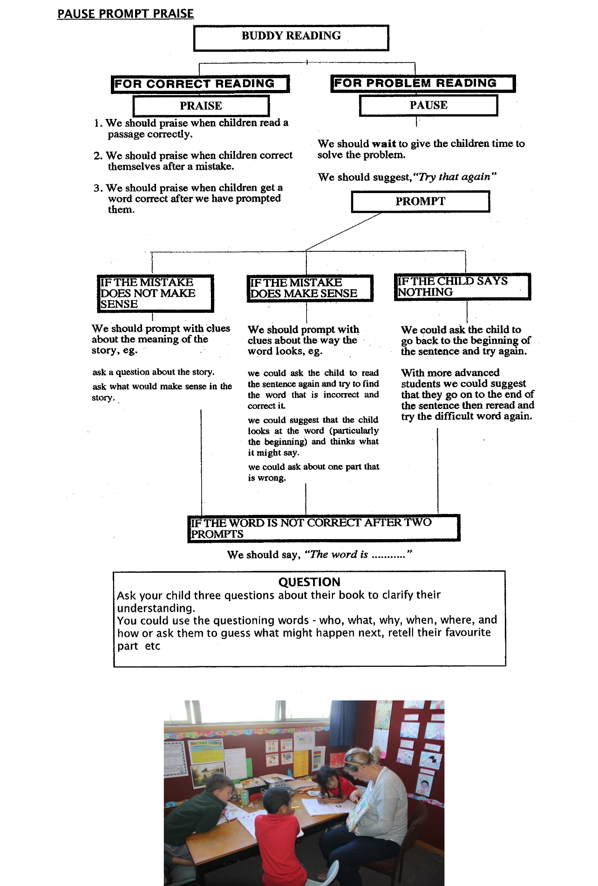

16
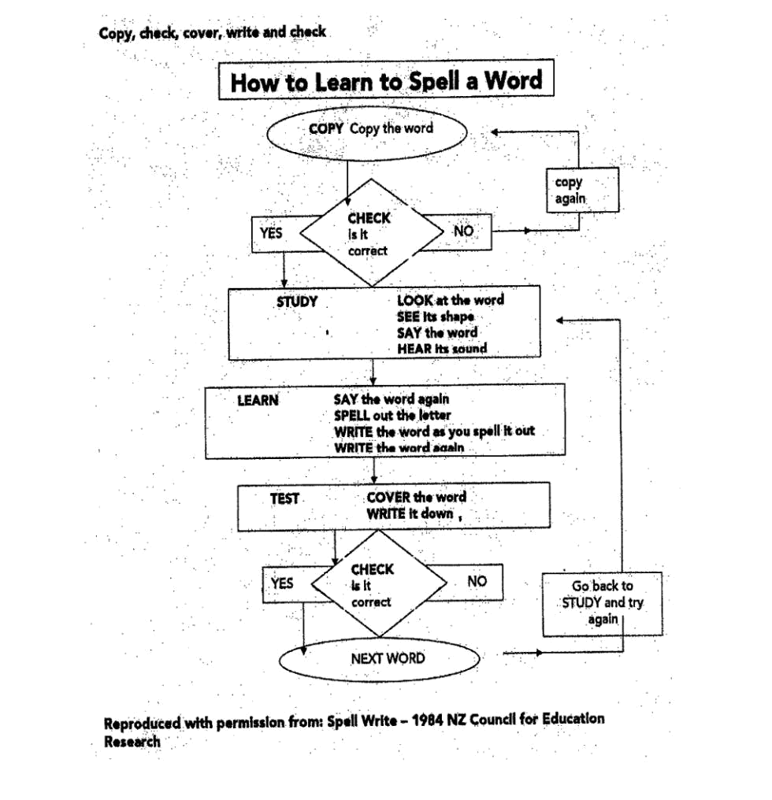

Question

Ask your child three questions about their book to clarify their understanding. You could use the questioning words – who, what, why, when, where and how or ask them to guess what might happen next, retell their favourite part etc.

Learning

At St John’s School we encourage all children to develop knowledge and the key competencies of confident life long learners.

- Relating to others

- Managing self

- Thinking

- Participating and contributing

- Using language, symbols and texts

Please help your child to become responsible for their own learning. At school we expect them to return their reading books every day, hand their homework book in for marking, ensure they have their fitness clothes at school, return their library books, deliver newsletters to parents etc. By taking responsibilities for these tasks they quickly learn valuable life skills.

17
Injuries

All children are expected to take part in daily physical education. If your child has an injury, please let us know, so we can ensure their safety.

Lost Property

This is not a major problem. Parents can help by encouraging and expecting children to look after their clothing. If uniform items are clearly labelled they tend to be quickly returned to the rightful owner. Children at St John’s School are encouraged to be responsible for their own clothing. At school they are asked to put jerseys etc in their bags when they are not wearing them.

We have found that some toys are not robust enough to stand up to a day at school. Please encourage your child to act responsibly when selecting items to bring to school.

Lunches

Children sit down for the first fifteen minutes from 12.30 – 12.45pm and are encouraged to take any uneaten lunch home. Children are encouraged to take home lunchtime rubbish. The children usually leave it in their lunch boxes. St John’s School encourages Healthy Eating and children have a healthy snack at 10am each morning, this can be fruit (fresh or dried), vegetables etc.

At times the Young Vinnies (Senior Class) provide a hot milo in winter at a minimal cost to students and baking on other days, “Yummy Tuesdays”, this is to raise money for a nominated charity. A notice will come home with students prior to these events.

We are lucky enough to have a microwave, pie warmer and toasted sandwich maker at school which the children may use at lunch time to heat food or drinks. Senior and Middle Class children are very good at helping Junior children with this if needed.

18
Medication

No medication may be administered to a child without parental consent.

Paracetamol may be given with verbal consent from a parent.

If your child needs to take medication during the day, please write the instructions clearly and send the medicine to school with your child. The named medicine must be handed in to the school office before 8.45am, where it will be stored in a safe place. Some children have medicine at school for emergencies (asthma, bee stings etc) and this is kept in the First Aid Cabinet. If your child has a medical problem, please let us know.

While staff will do their best to ensure that medicine is appropriately administered, they cannot accept any responsibility.

Mufti Days

At various times throughout the year, the school holds mufti days to raise funds for nominated charities such as Loud Shirt Day etc. A notice will come home to inform you when these days occur.

At times children also wear mufti when an activity outside of school occurs, e.g.

curling and skating as children need to wear warm clothing on those days.

Newsletters

School newsletters are given to the eldest or only child to deliver to you every third Friday, as well as emailed out to all families. We welcome, community contributions of news items, children’s success in activities outside school, events, snippets or anything of interest to the school, to be included in this newsletter. Just write a note on a piece of paper and send, email or fax it to the school office and we will publish it in the next newsletter. If you are asked to return forms attached to the newsletters, your prompt co-operation is always appreciated. We ask for your permission before taking the children outside of School. If we do not have permission for your child to take part in an activity, he/she will be unable to attend or take part.

Other times we have short notice of an event or reminders and will send home a short school notice to keep you informed.

If you do not appear to be receiving your newsletter, please phone the school.

We make every effort to keep the parents informed of the school programme.

19
Parent Help

We encourage parents to visit the classrooms. Teachers will request parent support when needed. A note will come home regarding specific need, please complete and return.

Parents are assisting us greatly in the following areas:

Reading support, art, supervising and transporting children for sports/educational visits, coaching athletics and Rippa rugby, special events e.g. Pet Day.

Parent Teacher Association (PTA)

What does it do?

The PTA has two key roles:

- To promote cohesion among our school family – parent to parent and parent to teacher

- To fundraise in the interest of better educational outcomes for our children.

An example of this is the Multi Purpose Turf which allows all students to benefit from a facility they can use all year round for playing, sports, activities. The PTA has committed to fundraise for this facility so that every child that goes through St John’s School is able to benefit from this great facility. The PTA arranges several other fundraising events over the year and funds raised supports the students and teachers at St John’s School. They also provide subsidies to student orientated activities, e.g. swimming lessons.

The PTA also has input into uniforms, for example the design and funding of the children’s new uniform.

The PTA has a chairperson, Angela Francis (03 4449926) with the role of running meetings and responsibility for any results the PTA wants to achieve and secretary, Geraldine Dowling who records all meetings and provides an Agenda so meetings are efficient, and treasurer, Katrina Suddaby who presents a financial report to each meeting.

Meetings are run formally with minutes taken. These parents are elected by nomination and vote at the AGM in May annually and any parent is welcome to make themselves available for these roles.

20
Meetings are held only when there is something to be done, sometimes after school or early evening, always at school. They are advertised in the school newsletter or by separate notice. The PTA is focused on finding ways parents can help with specific requests, even if they are unable to attend meetings.

If you have a topic the PTA needs to address or a good idea, come to a meeting or ring the chairperson directly.

Painting Shirts

Painting shirts are provided by school. These protect his/her clothes while painting.

Pedestrians

- Children should wear safety vests

- Children must walk on the footpath/grass

- Police Education Officers will be utilized, wherever possible, in road safety education units
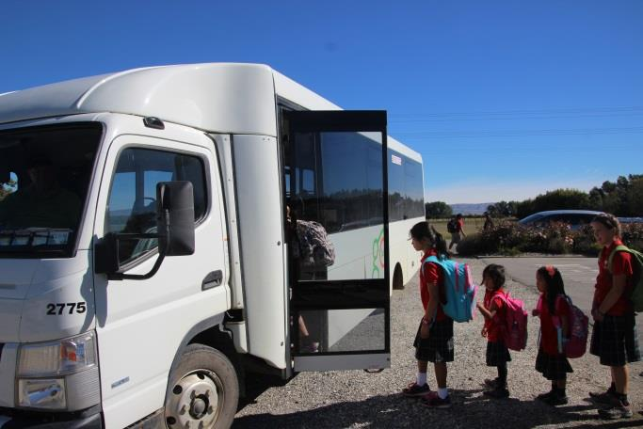

21
Phoning School

School Office: Fiona works: Monday 9am-1pm, Thursday 9am – 3pm and Friday 9am – 12pm.

Please phone 03 4449514 with messages during these hours if at all possible. Families are able to send a text to our school cell phone 027 266 1758 outside of these hours. Please be aware the cell phone is kept in the Junior Classroom so messages can be missed (especially in the afternoons) if it is a busy and noisy time. Otherwise the answering machine will collect a message but remember messages may not be checked after 1pm as all teachers are teaching.

Religious Education

Religious Education is taught at St John’s School. The programme teaches:

- what the Catholic Church believes and teaches

- understanding about how the Catholic Church celebrates, lives and prays

- how people can respond to God according to their gift of faith

Incorporated into everyday school life are the Gospel values we aspire to live by. Children take part in School Masses, liturgies and special Church celebrations at least once a term. Prayer is part of daily classroom routine.

Religious Education is a daily part of the curriculum at St John’s School. These lessons are at an appropriate level for the children. You are welcome to inspect the Religious Education Programme.
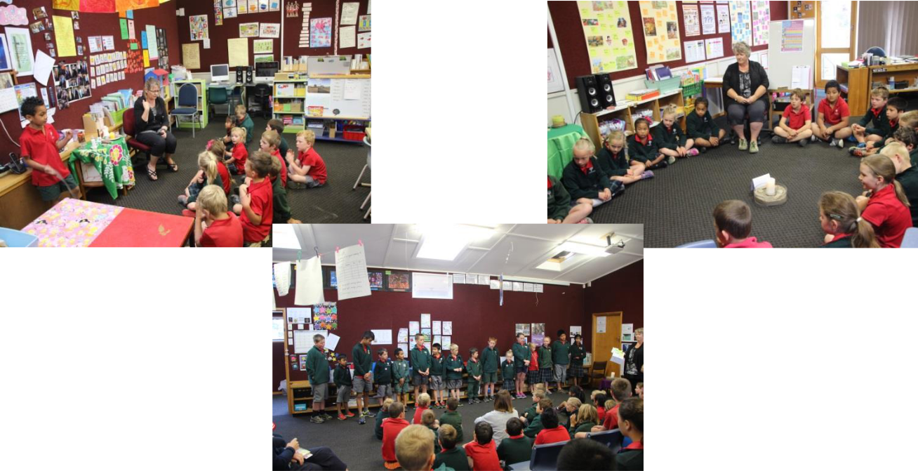

22
Reporting to Parents

If you wish to discuss your child’s progress at any time, please phone the school for an appointment with your child’s teacher.

You will receive a mid-year report and a final report. Portfolios are sent home at these times for parents/caregivers to view children’s work and then discussed at mid year teacher-parent interviews. You will receive a notice about this nearer the time, appointments are usually after school and in the evening.

Children in the Senior Class (Y6-8 may attend the teacher-parent interviews if you wish.)

Road Safety

PRIVATE MOTOR VEHICLE USE FOR SCHOOL RELATED JOURNEYS

Where private motor vehicles are used for school related journeys each vehicle must have:

- A current vehicle registration

- A current Warrant of Fitness and be legally roadworthy

- Both of the above must be clearly displayed in the vehicle

- A safety belt must be provided and worn by each passenger. The driver of the vehicle is responsible for ensuring all his/her passengers are wearing their safety belts correctly

- The driver of the vehicle must hold a current, full New Zealand driver’s license and agree not to use a cell phone while driving

- Parents/caregivers will be required to complete the private motor vehicle use consent form prior to any school related journey, this includes a copy of your driver’s license to be held at school.

- Booster seats are required for all students under 7 years old. The school does have spare booster seats at school but if someone else is transporting your child, if able, please leave their booster seat that day. Thank you.

Skateboards/Rollerblades

No child is allowed to bring the above into the school during term time, except when permission is granted by the principal.

23
School Costs

Presently there is no overall activity fee charged by the school. Parents pay for activities as they occur.

School Buses

A School Bus service is provided free for all pupils who live further than 3.2km from the school. A conveyance allowance can be paid to parents who have to drive their children more than 2.3km to catch the school bus, or to school if the school bus does not travel in your area.

The Bus Controller for the area is Maniototo Area School (MAS) teacher – Kelvin Robertson. Please contact MAS School Office (4449341) for any queries about the school bus. They will notify you of any changes. Please listen to BURN729 from 7am as bus notices will be announced following the News, e.g. bus running 1 hour late. Please help by ensuring your child is at the bus stop before the bus is due. Only eligible children may travel on the bus. If for some reason you may wish others to travel on the bus (birthday parties etc), please contact the driver.

In the event of an early school closure (snow on roads), we will attempt to phone all parents of bus pupils. If we can not contact you, or your designated emergency contacts, your child will be supervised at school until you can collect him/her.

Children must wear safety vests, so they are visible when getting on/off the bus in Term 2 & 3.

While riding on the bus all pupils are expected to remain seated and quiet. They are not permitted to eat while on the bus. After getting off the bus, children are to wait until the bus has moved away before walking home.

Bus children get on a bus at St John’s School which then travels around to MAS and children then get on the correct bus for transport home. It’s a good idea to communicate with your Bus driver when your child/children are not on the bus or there is a change to the usual routine your child/children have with the Bus. A text message is helpful for the Bus driver.

To ensure safety, children who travel by bus will travel home on the bus after school unless:

- We have received a note or phone call

- Someone known to us is at school to pick them up

24
If a child is travelling home by other means e.g. car, grandparents, please ring us at school, before 1.00pm Monday – Friday, to advise us, phone 4449514 or 0272261758. If, for some unforeseen circumstances, you pick your child up without ringing the school, please let the teacher on bus duty know that you have your child/children before they leave the school grounds.

BUS DRIVERS
• | Kyeburn: Shirley Hodge |  |  | 0275478580
• | Naseby: | John Lobb | 4449512 | 0211921414
• | Patearoa: | Kerrin Mulholland | 4449455 | 0223130867
• | Waipiata: | Malcolm Sayers |  | 0275490309

- Oturehua/Wedderburn: Nigel Voice 4449952 0275038753

• Gimmerburn: Murray Brasell | 4449482 | 0212959819

If you have any questions regarding the timetable of buses, please contact the bus driver. Any general questions, please contact MAS Bus Controller, 4449341.

BEHAVIOURAL EXPECTATIONS FOR STUDENTS USING SCHOOL BUSES

Students who travel on a bus may continue to do so while they behave in a reasonable and safe manner. The following behaviour is expected of students using buses to help make sure the bus is a safe place for everyone:

- Seated passengers sit down straight away and remain in their seats for the whole journey

- Standing passengers stay behind the driver at all times, stand quietly, and do not push or move around the bus

- Passengers do not eat or drink in the bus

- Passengers do not throw objects inside or out of the bus

- Passengers use socially acceptable language when talking to the driver and/or other students, and speak quietly so they do not distract the driver

- Passengers respect the bus operator’s property at all times (e.g. refrain from standing on seats or vandalising the bus in any way)

- Passengers do not harass, bully, or abuse other passengers or the driver in any way, whether verbal or physical

- Passengers respect others’ property and do not interfere with it in any way

- Passengers listen to, and follow the requirements and instructions of the bus driver and the teacher/s on duty at all times

- Passengers do not engage in any behaviour that could put other passengers, the driver, or themselves at risk. Any questions to Bus Controller.

Students who choose to behave in an unsafe and/or unacceptable manner risk losing their place on the school bus.

25
School Hours

- Children may arrive at school from 8.30am

- All children are expected to be at school by 8.45am. The school day starts at 8.50am

- Morning interval 10.40am

- Lunch 12.30pm

- School Closes & bus leaves 2.50pm

- All children must leave the school grounds by 3.15pm

School Mass

This involves students, teachers, parents, siblings, extended family, and the Parish Community and are held when appropriate, at least once a term. St John’s School celebrates St John the Bapist Day, Ash Wednesday and more. Support from parents on these days is always appreciated. Parish members attend also.


Sports

Sport plays an important part in the programme of any school, not only in the development of skills, fitness and in teamwork, but in the case of St John’s School, social contact with other children of the same age, interest and abilities. In the first term, swimming is the main feature, lessons then swimming sports. All children are involved in competitive and fun activities.

Other annual sporting events include: cross country, skiing, curling, ice skating, rippa rugby and athletics. The school has a set of sports shirts purchased by the PTA which the children wear on sports days. These are given out prior to sports events. Please wash and return your child/children’s top following the event, thank you.

26
Children join sport teams which are a combination of children from neighbouring schools and play for “Maniototo”. Winter sports include hockey, rugby, netball, ice hockey, curling. Summer sports include cricket, tennis. Lessons/coaching for sports are advertised in the Newsletter or a note home and/or word of mouth. Please ask other parents how to get involved if you are interested in your child/children being actively involved.
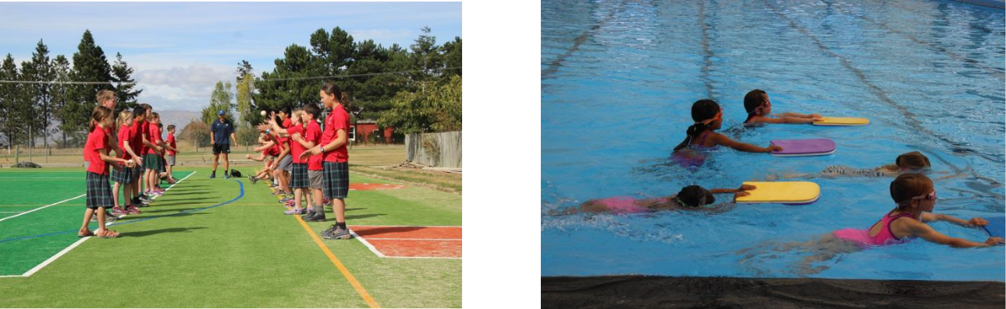

Sports Uniforms

Red School logo polo sports tops (these are held at school), given out to children when needed. Children can wear own trackpants, socks and black shorts.

Staff Meetings

School staff meetings are held weekly, on Tuesday after school. These meetings deal with matters of school organisation and professional development. These meetings deal mainly with the learning programmes, organisation of opportunities for children, and to decide issues relating to curriculum and school development.
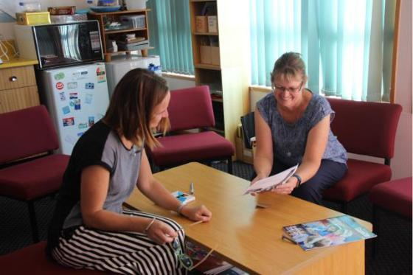

27

Stationery Purchases

At the beginning of the year, children receive a stationery list with highlighted items they need for the coming year and the cost. The school provides all stationery items.

Transport

We often rely on parents to provide transport for school outings. When this happens, children whose parents are not providing transport pay a fee to the driver of the car.

The rates are: Dunedin $10.00, Alexandra $5.00. This will be mentioned when a school trip is planned, otherwise there is no transport cost.

When you are providing transport for children for a school trip etc, the school requires a copy of your drivers licence to have on file.

Uniforms

St John’s School has a compulsory school uniform. As all uniform items tend to look the same, please ensure all clothing is named. At school we aim to foster independence by encouraging children to take responsibility for their own clothing. Stray items are placed on spare corridor hooks, and children are permitted to look for any lost items before or after school.

Items which have not been claimed at the end of the term are disposed of. Orders for school uniforms can be made through the school office.

GUIDE-LINES

- If a child is unable to wear the correct uniform, a note is required from the parent

- Children must wear school uniform to and from school

- Uniform items are ordered through the school office (except shoes, socks)

28
GIRLS – SUMMER/WINTER

Red polo shirt, Culottes, School polar fleece/jersey, Black socks (stockings in winter), Brown or black shoes or sandals

BOYS – SUMMER/WINTER

Red polo shirt, Grey shorts, (trousers in winter), School polar fleece/jersey, Black socks, Brown or black shoes or sandals.

Hair ribbons etc – black, brown, red or green.

Sunhats are purchased with stationery at the start of the year and must be worn at school during daylight saving.

Jewellery: One pair of stud earrings or sleepers only. No other jewellery permitted. Only clear nail polish is permitted.

In winter conditions, children are encouraged to wear layers of warm/waterproof clothing.
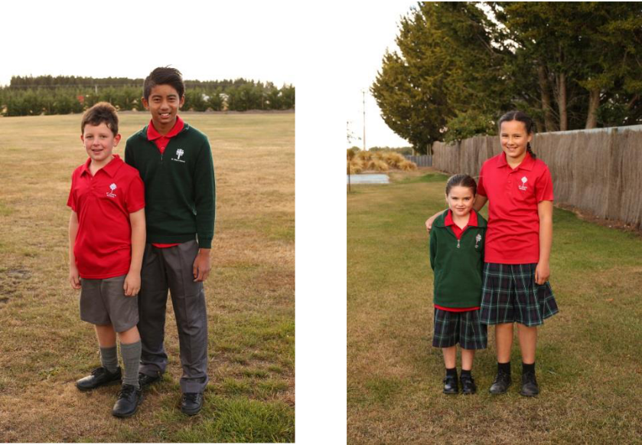

Visitors

- All visitors must report to the school office

29

