St John’s School Newsletter

School

6 Stuart Road
Ranfurly
03 4449514 (ph & fax)
office@sjr.school.nz
St John’s
School

Issue 10: 16th October 2020
Principal’s Page:

Welcome Back
Welcome back to everyone for the final term of 2020.

National Shake-down drill
On Thursday we all took part in the nationwide earthquake shakedown drill at 9.30a.m. Children were familiar with Drop, Cover, Hold. Each class practised and discussed what to do in an earthquake.

Loud Shirt Day
Each year we participate in the fundraiser for New Zealand cochlear implants for the deaf and hard of hearing community - “Loud Shirt Day”. This is happening next Friday 23rd October and we ask children to come along to school in bright, colourful mufti clothes and to please bring along a gold coin donation for this cause. Thank you.

Labour Weekend
School is closed on Monday 26th October, for Labour Weekend.

Athletic Sports Practises
Thank you to those parents who have sent along forms saying they can help out with our school athletic practises on Friday afternoons 16 October, 23 October and 30 October. Please just turn up at 1.20p.m. on the days you indicated and we will get you to help with an athletics activity.

Fonterra Milk in Schools
You may have read that this programme is ending at the end of 2020. Fonterra are instead going to increase the supply of milk to schools through a breakfast programme in low decile schools. We will continue to have milk until our supplies have gone.

Special Character Clipboard:

* A reminder for the 1st Holy Communion children and parents, that these children will be making their Confirmation on Sunday 8th November at 5p.m. Mass with Bishop Michael Dooley. Mrs Jeffries will be preparing them over the next few weeks for this celebration.

* All classes will be working on the “Communion of Saints” strand this term and then learning about Advent. The word “advent” is a latin word meaning “the coming”. Advent is the time in the Christian calendar when we prepare and remember the joy that the birth of Jesus brought to the world.

Junior Class News:
Firewise Programme
This term the children are working on a “Firewise” theme with Mrs Elworthy. It is a unit where children learn about keeping safe around fires, and knowing what to do if there is a fire in a room. Children also learn and practise calling 111 in an emergency, so if your child does not know their address/rapid number it would be a good chance for them to learn this now.

Balmoral Book Bonanza
New pizza wheels will be given to each Junior Class child next week for their Term 4 Balmoral Book Bonanza. Juniors need to complete two pizza wheel book reviews and talk about their book to Mrs Mulholland before they receive the Balmoral hot chips voucher. They can bring the book along to school and share it with the class if they would like to.
Thank you to Mr and Mrs Cai for the hot chips and chicken nuggets that children received last term. It was a great incentive to read and the children loved the hot chips and nuggets!
Middle Class News:

Kia Ora and welcome back to term 4!

The students have come back settled and we have been able to get straight back into our routines which is great! This term will be jam packed with Athletics, end of your testing and reports as well as preparing for and performing the Nativity play at the end of the term.
With the warmer weather and athletics training that we are doing, it is important the students have water bottles every day as well as putting on sunscreen in the mornings! We do provide sunscreen at school and will remind the students about sun safety but please do reinforce this at home.

I would like to welcome Ange Francis to the Middle room team! Ange will be working in our class 4 days a week during maths and writing! She has already established herself in the class as the funnest teacher (why do I always have to teach the boring stuff) and the kids love interacting with her!

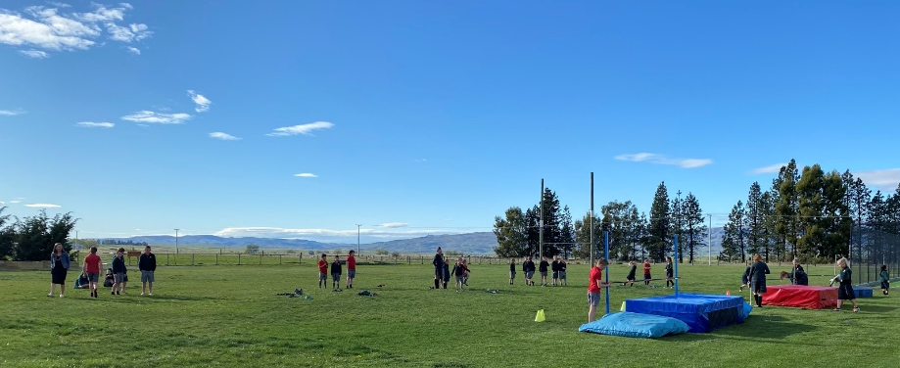
Here is a snapshot of our amazing students all practicing high jump before school.
We are super dedicated!
Senior Class News:

Deep breath - a big term ahead!

Kia ora

Welcome back for the final term of the year. As usual we have a lot going on and I have included a list of dates at the end of the newsletter. More could be added to this as we finalise our term details.

Young and Healthy Virtual Adventure
This starts next Tuesday, which is good timing as we will be getting fit and ready for triathlon and athletic sports. The children will enter exercise data online and travel virtually throughout the world. The main aim of this activity is to build the children's understanding of the importance and value of daily activity, sleep and good eating.
Details on how to join us in this were in the last newsletter of term 3. You are most welcome to join us on this journey.

Balmoral Book Bonanza
I am continuing to receive work towards this and our goal is to have everyone achieve their hot chip token by the end of the year. We can do this!

Kiwi Sport Curling
Tournament day was on Tuesday and we had a great day out with some really challenging games and pleasing results.
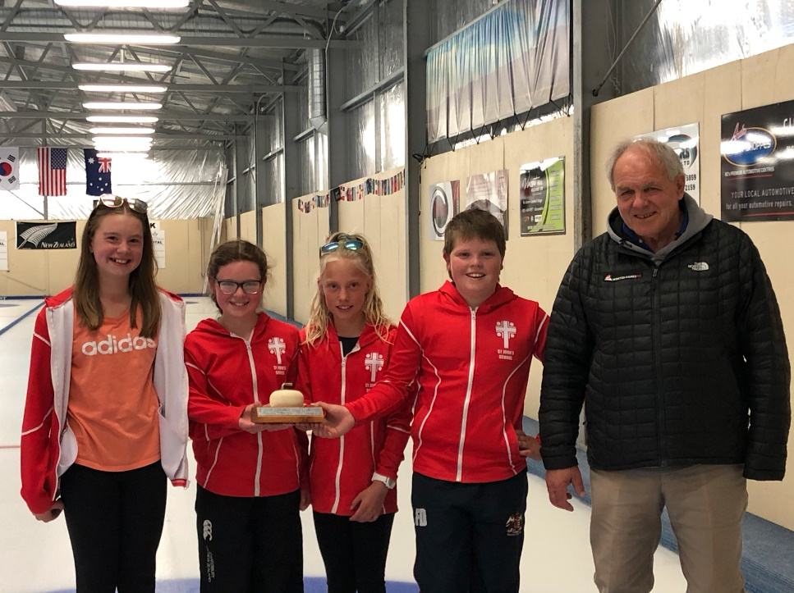

Congratulations to Tessa, Paige, Chloe and Fred who won the year 5 / 6 section. Well done. Those smiles say it all.

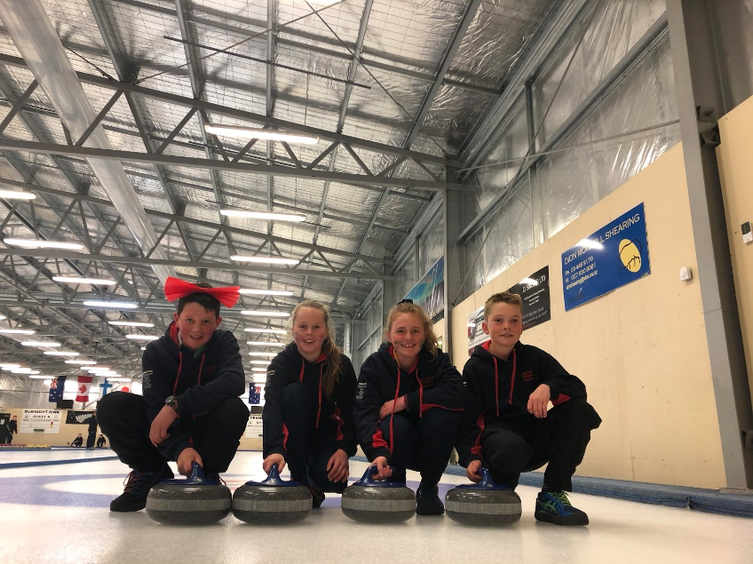

We also placed third in the Year 7/8 section. Congratulations to Jake, Annie, Paxton and Toby, I think that big red bow brought good luck to this team.

Tuesday was a great day out for all teams participating in the curling tournament, there were lots of tough games but this is what made it fun. A big congratulations to the year 5 & 6 team who placed 1st in their category, this is a big achievement so well done. It was exciting to see the MAS children there and it was fun being able to play with them.

Curling is a great team game and is very skillful and not as easy as it looks, it's awesome that we have a great facility to use at our back door step. I encourage you to give curling a go and I am sure you will love it.

Some comments from the kids who participated in the tournament were

‘It was fun to see all my friends from the MAS and my team had fun’

‘It was very well organised and fun’

‘The competition was exciting and it was cool to compete against all of my friends from MAS, my team didn’t do as well as we hoped but everyone tried really hard’

‘It was really cool - especially for my first curling tournament’

By Annie Dowling

Dunstan Zone Triathlon
This is on Wednesday 4th November in Cromwell and we are working out our entries at school. A notice for those going will come home on Monday 19th. The place getters from the Dunstan Zone Triathlon will go on to compete in the Central Otago Triathlon Championship event in Queenstown on Wednesday 18th November. At this stage I know no details about this event.

Term dates (as I know them at the moment)
Tuesday 20th October - Y7 Vision Screening
Friday 23rd October - Loud Shirt Day (mufti with a gold coin donation)
Monday 26th October - Labour Day so no school
Wednesday 4th November - Dunstan Zone Triathlon
Friday 6th November - Maniototo Athletic Sports
Sunday 8th November - Confirmation Mass 5pm
Tuesday 17th November - Otago Athletic Sports (pp Thursday)
Wednesday 18th November - Central Otago Triathlon Championship
Monday 23rd November - Science Roadshow
Tuesday 24th November - ABL Day at the Waiora Scout Camp (near Dunedin)
Thursday 3rd December - School Concert and Prize Giving
Friday 4th December - Pet Day
Monday 7th December - Year 8 Graduation
Tuesday 8th December - Rafting day near Outram
Wednesday 9th November - Last day of school!

Dates to be confirmed - End of year School Mass and reports / portfolios coming home.

Thank you
Geraldine Duncan

Board of Trustees
:

*At our October meeting a curriculum report on “Science” was presented.

*Five BOT members attended a Catholic Schools’ BOT meeting in Cromwell in the last week of Term 3. This was an informative evening with Bishop Michael, Father Gerard Anysley and Callan Goodall, who together, run the Otago/Southland Catholic Education Office. Some of the topics discussed were: attendance dues, property issues and attracting teachers to our Catholic Schools.

*Our next Board meeting is on 10 November at 7.30p.m.

Notices and Dates:

Week 2 | Friday 23rd October | Loud Shirt Day  (mufti with gold coin donation)
Week 3 | Monday 26th October | Labour Day (no school)
Week 4 | Wednesday 4th November | Dunstan Zone Triathlon
 | Friday 6th November | Maniototo Athletic Sports
 | Sunday 8th November | Confirmation Mass 5pm
Week 5 | Tuesday 10th Nov | BOT meeting 7.30pm
Week 6 | Tuesday 17th Nov | Otago Athletic Sports (pp Thursday 19th Nov)
 | Wednesday 18th Nov | CO Triathlon Championship
Week 7 | Monday 23rd Nov | Science Roadshow
Week 8 | Thursday 3rd Dec | School Concert & Prizegiving
 | Friday 4th Dec | Pet Day
Week 9 | Wednesday 9th Nov | Last day of school

