St John’s School Newsletter

School

6 Stuart Road
Ranfurly
03 4449514 (ph & fax)
office@sjr.school.nz
St John’s
School

Issue 9: 25th September 2020
Principal’s Page:

Laura’s Marathon Run
Congratulations to the Young Vinnies and all children and families who supported Laura’s Marathon Run. $4,426.50 was raised to give to the Maniototo Support Network. What an amazing effort!
Also a big thank you for contributions of food that were also donated to the Support Network.

Mass Time
Sunday Mass time has now changed due to daylight saving. Mass, as from Sunday 27th September, will now be at 5p.m.

Raised Vegetable Gardens
The three raised vegetable gardens have been built. Thank you to the PTA and Geraldine Dowling for organising this for us. The Senior Class had a working bee on Wednesday afternoon to prepare the gardens and each class will decide what they are going to plant after the holidays. Thankyou also to Ryan & Geraldine Dowling, Gerald Dowling & Kim Gibson who came & helped with this.
Thank you to the Middle and Senior Classes who also helped by picking up all the sticks and bits of branches in the ground where the mounds once were! This is ready now to be dug and smoothed over by a machine.
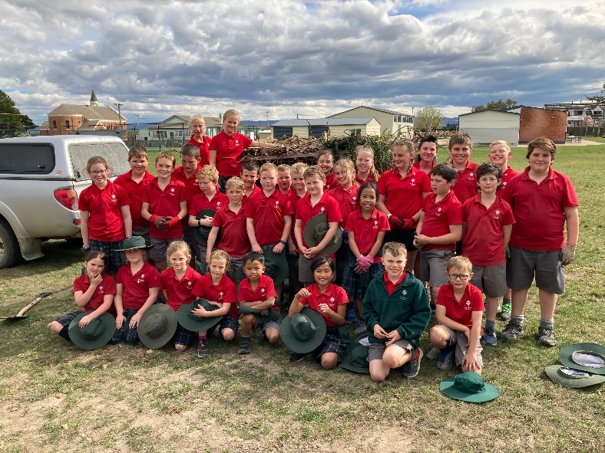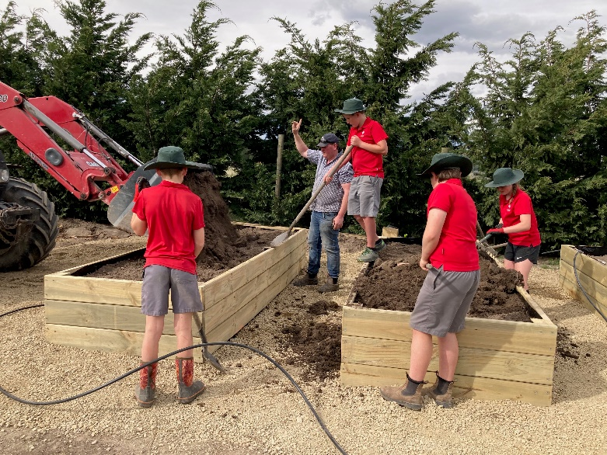

Bus Vests
Teachers have collected these in now for the summer months. If your child hasn’t done so, could they please give their bus vest to their classroom teacher, thank you.

Term 4 dates
It has been great to have been at school for the whole 10 weeks of this term. It is amazing to think we are nearly into Term 4!
Term 4 begins on Monday 12th October and the last day of school for 2020 is Wednesday 9th December.

End of Year School Concert
This is going to be held on Thursday 3rd December in the Ranfurly Town Hall.

Labour Weekend
School is closed on Monday 26th October for Labour Weekend.

Athletic Sports Practises
Athletic sports will come around quickly next term. The date is likely to be Friday 6th November, with postponement date Monday 9th November. This will be confirmed nearer to the time.
We will be having three practises at school - Friday 16th October, Friday 23rd October and Friday 30th October from 1.20 - 2.30p.m. (approximately).
Once again, we would like to ask for parent help with these practises. If you can help with taking an activity (high jump, long jump, throwing, running or hurdles), please fill in the attached form indicating dates you would be available to help and return the form to school after the holidays.
Please then just turn up at 1.20p.m. on the days you indicated. Thank you.
Please note you do not have to be an expert at any of these things just willing to supervise and encourage the children.

Have a safe and happy holiday.

Special Character Clipboard:

Congratulations to the nine children who made their First Holy Communion on Sunday 20th September:
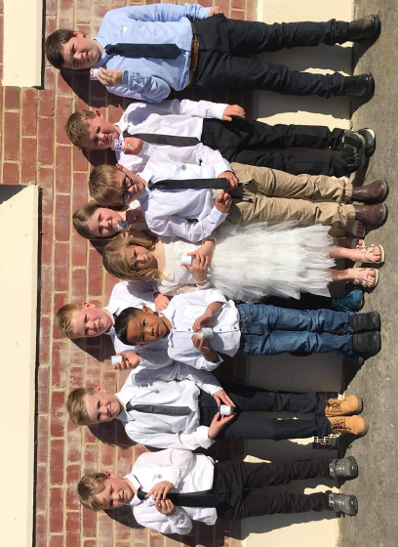
George Dowling, Marley Weir, Finn Dowling, Harry Dowling, McKinley Francis, Cyrus Janerol, Harry Jeffries, Jae McAuley and McKenna Suddaby.
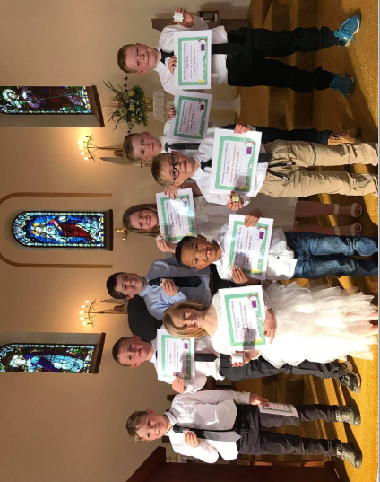
They all looked great and enjoyed their very special celebration.

Junior Class News:
*We all loved wearing our marathon t-shirts on “Laura’s marathon day”. Here we are:
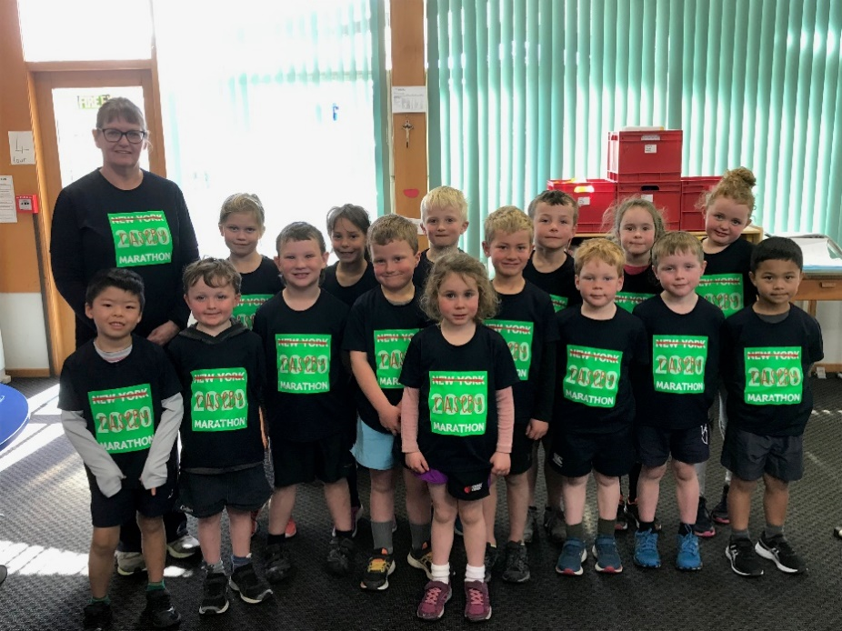

*On Wednesdays with Miss Flintoff and Thursdays with Mrs Elworthy, the Juniors have been growing plants so we have some seedlings to plant in our planter box early next term.
Here are some photos. The bottom one shows the children wearing their “Little Garden League” member badges.

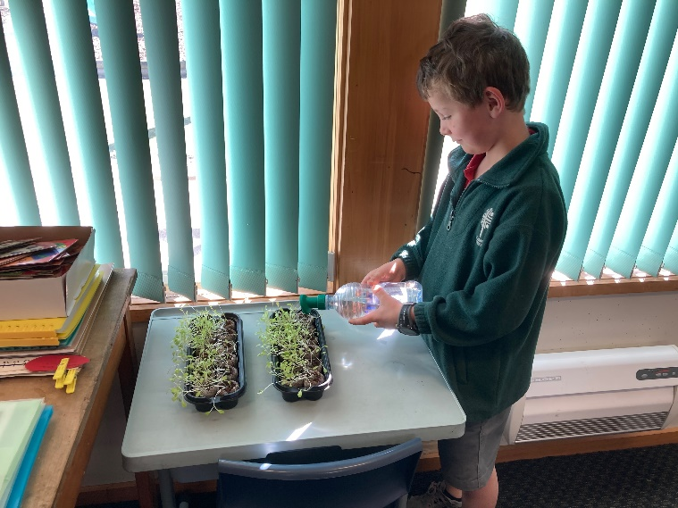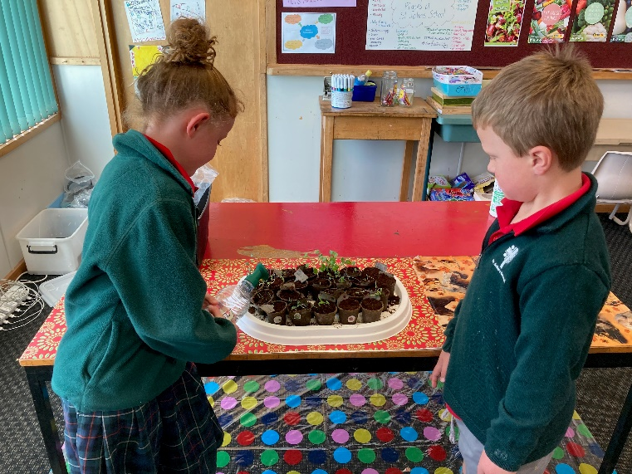
Middle Class News:
Congratulations to all the parents and students! We have survived our first full term this year, and what a term it has been. There have been so many highlights this term - Curling, Cross Country, the destruction of the school mounds, the building of the vegetable gardens, as well as achieving so much in the classroom!
The students in the middle room have been flat out finishing their calendar art with the help of Mrs Hazlett and they look AMAZING. I am sure there will be some very happy family members come Christmas time.

The Naseby Marathon was a huge success and the students had a great time running around the Naseby Forest. Afterwards the students had some great stories to write.

On Monday the 7th of September it was a warm and sunny day at the Naseby Swimming Dam but it was not just an ordinary day. St Johns school held a marathon with one of their old pupils, Laura Dowling.  P.S she is my cousin.  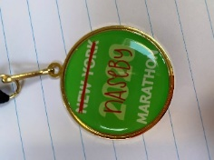  We didn’t go there to support her with her shoe laces, we went there to support her with her first marathon! She was supposed to be going to New York for her marathon but because of covid, she couldn’t travel and that is why she did it down in lonely old Naseby not in the populated New York. I ran 14.42km and I was shocked that I beat my record for running by 7km. Marley, McKinley, Josie, Logan and I all ran the same distance. At the end my Auntie Michelle did an early celebration but Laura still had 2km to go! 5 minutes later she came back with a face as red as a tomato. Afterwards Laura said a speech and there was a little surprise! A gold medal for everybody.  George Dowling | Woohoo! On Monday the St Johns School and I drove to the Naseby Dam. We drove there because we were supporting Laura Dowling while she did her Marathon! Cyrus and I ran together all day. I ran 2x the Hepi Highway Loop and 2x the Forest Walk Loop with Cyrus. I did 7x around the dam, it was easy! At the end of the day we got medals and Ice Blocks! After that we went home.  Hayley Barroga.

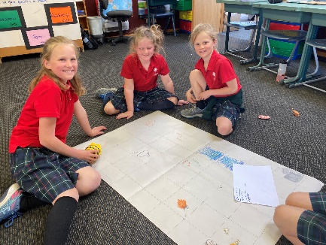  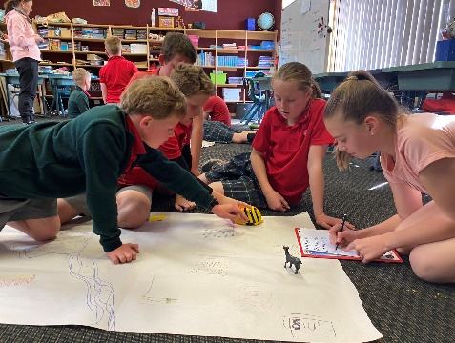  We have been working together a lot as a school over the last couple of weeks with the seniors becoming experts in Beebots and teaching the rest of the school, as well as school wide buddy reading. It is great to be able to share our knowledge and work together between classes. | 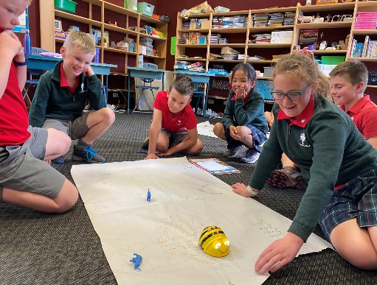  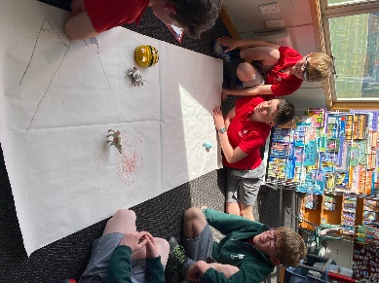  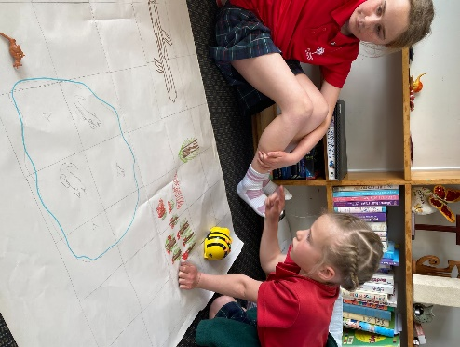  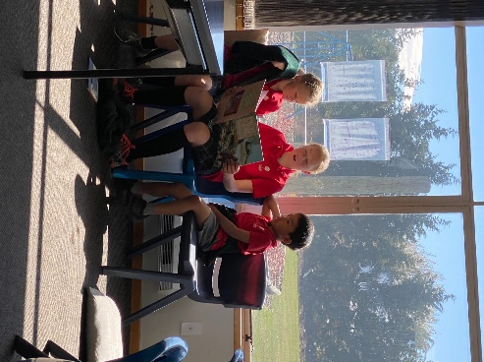

Senior Class News:

Drink lots of water

Kia ora whanau

Young and Healthy Virtual Adventure
We will be participating in this activity next term and wearing pedometers to measure our steps. The information below is from the organising team - please join us in our efforts to be healthy and active.

In Term 4 our class is participating in the Zespri Young and Healthy Virtual Adventure that runs for 5 weeks starting on the 20th October. It's a fun journey around the globe, encouraging our children to engage in healthy habits every day, like; moving as much as possible, eating fruit and vegetables, drinking plenty of water and sleeping well. This will earn us points to move our class team around the virtual course. We all create our own unique avatars that we will see in short videos of each location that we "visit" with the points we achieve each day. We'll be led and inspired on our journey by ASICS Ambassadors; Ardie Savea, Ameliaranne Ekenasio, Kane Williamson and Samantha Charlton.
You can join us on our journey. Here is how you can get involved:
1. Join the Whanau Team
Join in the fun by taking the same challenge to track your own healthy behaviours supporting and encouraging your child along the way! You just need an email address and a phone or other device to access the event App.

Click this link and enter your details: https://register.healthykids.kiwi/SetupGuardian1.aspx?team_id=16748&cli_id=1400&checksum=C57B7B3DC625E572A6EDE0C5C91477F4 NOTE: The Password field on the form is for you to create your own to use to login to the App later.
Once done, you'll get an email confirming your place and letting you know what to do next. The App will be ready before the program starts, so we will send you details on how to find it before then. You are welcome to share the link to invite other family members or class parents to join in too.
2. Sign up to receive regular email updates
Packed with healthy tips and tools that you can try at home with the whole family, and weekly mini-challenges you can win prizes for. You'll be kept updated on where in the world the children are going on their Virtual Adventure. Email supportcrew@teamchallenge.co.nz to go onto the list for updates from the Zespri Young and Healthy Virtual Adventure support crew.
To find out more go to www.youngandhealthy.org.nz and read the Parents section of the website.

Balmoral Book Bonanza
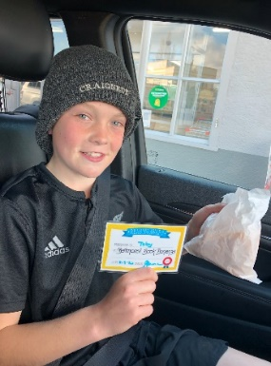
Many of our class have enjoyed their hot chips and chicken nuggets over the last few weeks as they have completed their activities. All of the children assured me that these were delicious and they were very excited to find some extras in their bags - chicken nuggets. Thank you Mr and Mrs. Cai.

Kiwi Sport Curling
This is on the first Tuesday of term 3. You will have already received the information regarding who is in what team and details for the day.
Our travel details are as follows - drivers please be at school ready for departure at 9.15am.

Geraldine Duncan | Becky Bruhns  (up only) | Geraldine Dowling | Anna Greer | Judy Hore
Toby  Tessa  Billy  Chloe | Grace  Paxton  Jake  Paige | Annie  Fred  Ben  Tom | Elliot  Ryan  Luke | Phoebe  Liv  Georgia  Alyssa  Rosa  Grace (back only)
At the end of the day: Jake, Paige and Paxton stay in Naseby

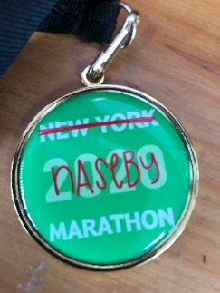
Laura’s Marathon / Food Bank fundraiser
What a success this day was!
- Laura ran 42km in 4 hours 43 minutes
- The Senior Class covered 321.98km in total
- O’Neill House ran 177.49km
- McAuley House 144.59km
- We had amazing support from you.

The very special news is that we raised a whooping $4426.50 for the Maniototo Support Network. Just incredible! I was so proud of Laura and her huge effort and positive mindset - she smiled all day and also the determination and fitness that the children showed. I am so proud to be part of our school and to be a member of a super classroom.

The raffle
We have been given some more items that we have added to our raffle prizes - Maniototo Contracting tee shirts and a beautiful hand knitted blanket. Thank you to the Hore family for these kind donations.
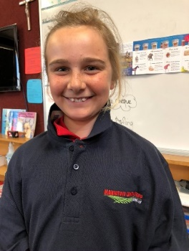

The raffle winners are …
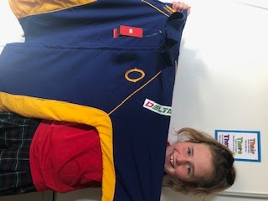

Otago Rugby training Jacket Hand knitted blanket
Maniototo Contracting tee shirt Chocolates
Chocolates

The winner is Aroha Cromb The winner is Marie Eagles

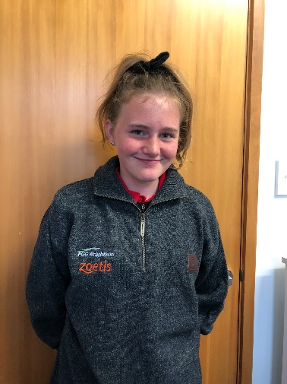

Highlanders Top Swandri Jersey
Donated by the Otago Sports Depot Donated by PGG Wrightsons
Maniototo Contracting tee shirt Maniototo Contracting tee shirt
Chocolates Chocolates

The winner is Jo Herd The winner is Dianna Whyte

Thank you once again to our generous sponsors:
- Breen Construction
- Southern Wide Real Estate
- Hazlett Contracting
- PGG Wrightsons
- Otago Sports Depot
- Foleys Plumbing
- Maniototo Contracting Ltd
- Maniototo Four Square
And to the Naseby Holiday Park for allowing us to use their toilet facilities during the day.

Holidays
Enjoy this time with your children and be happy together. If you have time, please check up on and practice telling the time with your child on both an analogue and digital clock. I have noticed that some of the children find this challenging and it is a skill that gets better with lots of real life practice.

Encourage your children to stay active over the holiday break and we will be into athletics training as soon as we return from the holidays.

Kia pai to hararei - have a nice holiday.

Thank you
Geraldine Duncan

Notices and Dates:

Week 1 | Monday 12th October | First day of Term 4

Graeme Laing Swim School
We wish to confirm that we are very
Fortunate to have Graeme (Billy) Laing
- NZ Swim Coach Legend back to Ranfurly
For another year
Billy’s lessons will again run from 27th – 31st December.
Registrations will be taken in Term 4.

-------------------------------------------------------------------------------------------------------------------------------
Athletic Sports Practises

I can help with athletics coaching at school from 1.20 - 2.30p.m. on

Friday 16 October

Friday 23 October

Friday 30 October

(Please tick dates that are suitable)

Name:_____________________________________________________

