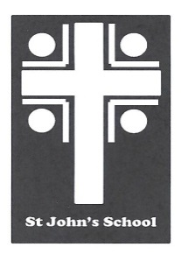
St John’s School Uniform Order Form – Shorts (Adults) St John’s School
Contact Name Date 6 Stuart Road
Student Name Ranfurly
Address Town Email: office@sjr.school.nz
Email
Phone Mobile

Uniform Order Details |  | Sizes Available – Enter Quantity Required
Product | Colour | 76 cm | 80 cm | 84 cm | 88 cm | 92 cm | 96 cm | 100 cm | Price | Total
Elastic Shorts | Grey |  |  |  |  |  |  |  | $40.00
Tab Shorts | Grey |  |  |  |  |  |  |  | $48.00
Postage |  |  |  |  |  |  |  |  | $7.00 | $7.00

Delivery Details Payment Details Total:
All orders will be delivered to the school. |  | Payments to be given with the orders. Cheques made out to St John’s School Uniform Account or paid by internet to  03-0951-0045351-000. Please use name as a reference. Thanks

