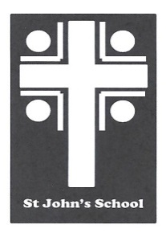
St John’s School Uniform Order Form – Polo Shirt (Adults) St John’s School
Contact Name Date 6 Stuart Road
Student Name Ranfurly
Address Town Email: office@sjr.school.nz
Email
Phone Mobile

Uniform Order Details |  | Sizes Available – Enter Quantity Required
Product | Colour  (Half chest (cm) | S  53 | M  55.5 | L  58 | XL  60.5 | 2XL  63 | 3XL  68 |  | Price | Total
Polo shirt | Red |  |  |  |  |  |  |  | $32.00
Postage |  |  |  |  |  |  |  |  | $7.00 | $7.00

Delivery Details Payment Details Total:
All orders will be delivered to the school. |  | Payments to be given with the orders. Cheques made out to St John’s School Uniform Account or paid by internet to  03-0951-0045351-000. Please use name as a reference. Thanks

