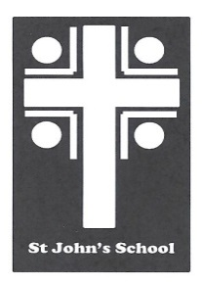
St John’s School Uniform Order Form – Polar Fleece (Adults) St John’s School
Contact Name Date 6 Stuart Road
Student Name Ranfurly
Address Town Email: office@sjr.school.nz
Email
Phone Mobile

Uniform Order Details |  | Sizes Available – Enter Quantity Required
Product | Colour  (Half chest (cm) | S  57.5 | M  60 | L  62.5 | XL  65 | 2XL  67.5 | 3XL  70 | 4XL  72.5 | Price | Total
Polar fleece | Bottle |  |  |  |  |  |  |  | $43.00
Postage |  |  |  |  |  |  |  |  | $7.00 | $7.00

Delivery Details Payment Details Total:
All orders will be delivered to the school. |  | Payments to be given with the orders. Cheques made out to St John’s School Uniform Account or paid by internet to  03-0951-0045351-000. Please use name as a reference. Thanks

