St John’s School Newsletter

School

6 Stuart Road
Ranfurly
03 4449514 (ph & fax)
office@sjr.school.nz
St John’s
School

Issue 5:
Principal’s Page:
Cross-country
What a welcome to spring with snow on day 1 which was supposed to be cross-country day.
Congratulations to all the children for their effort and running on Thursday. Well done, everyone.
The timed results have been collated with Maniototo Area School and overall winners have been announced.
Here is a list of the place-getters. Congratulations to those children.
No certificates are given out for individual school results. As this is officially a “Maniototo Cross Country” only those overall winners in each age group, between St John’s and M.A.S. are awarded certificates.

MANIOTOTO CROSS COUNTRY 2020 RESULTS
Year 1 Girls
1st | Esme Hore | MAS
2nd | Sophie McAtamney | MAS
3rd | Juliette Dowling | St John’s
Year 1 Boys
1st | Toby McFadyen-Beck | MAS
2nd | Bede Paterson | MAS
3rd | Oscar McAtamney | MAS
Year 2 Girls
1st | Nikita Wilson | MAS
2nd | Thalia Hepi | MAS
3rd | Isla Jeffries | St John’s
Year 2 Boys
1st | Xavier Love | St John’s
2nd | Arthur Elworthy | St John’s
3rd | Leo Finlayson | MAS
Year 3 Girls
1st | Vanessa Kinney | MAS
2nd | Laura Paterson | MAS
3rd | Isla Drake | MAS
Year 3 Boys
1st | McKinley Francis | St John’s
2nd | Jae McAuley | St John’s
3rd= | Harry Dowling  Tyrell Hore | St John’s  MAS
Year 4 Girls
1st | Marley Weir | St John’s
2nd | Josie Herlihy | St John’s
3rd | Lexi McFadyen-Beck | MAS
Year 4 Boys
1st | George Dowling | St John’s
2nd | Logan Suddaby | St John’s
3rd | Axel McAuley | St John’s
Year 5 Girls
1st | Shaylah Pink | MAS
2nd= | Marley Hore & Macy Finlayson | MAS
3rd | Indianna Hepi | MAS
Year 5 Boys
1st= | Eddie Weir  Max Gregan | St John’s  MAS
2nd | Sam Elworthy | St John’s
3rd | Callum McSkimming | MAS
Year 6 Girls
1st | Tessa Steele | St John’s
2nd | Amelia Smith | MAS
3rd | Susie Smith | MAS
Year 6 Boys
1st | Thomas Helm | MAS
2nd | Ben Gibson | St John’s
3rd | Nate Spooner | MAS
Year 7 Girls
1st | Ruby Hore | MAS
2nd | Isabelle Helm | MAS
3rd | Sam Roxburgh | MAS
Year 7 Boys
1st | Ethan McSkimming | MAS
2nd | Toby Duncan | St John’s
3rd | Ryan Crossan | St John’s
Year 8 Girls
1st | Annie Dowling | St John’s
2nd | Lucy Falconer | MAS
3rd | Paxton Francis | St John’s
Year 8 Boys
1st | Nic Pieterse | MAS
2nd | Jake Smith | St John’s
3rd | Luke Shead | St John’s

Laura’s Marathon Run
A reminder this is on Monday 7 September. Each class is going up to Naseby at different times:
Seniors leaving school at 8.40a.m.
Middle Class leaving school at 10.50a.m.
Juniors leaving school at 12.50p.m.
Children need to bring their sponsor sheet and money collected to school on Monday please and give it to the classroom teacher.
You should have received a final organisation letter for this day on Wednesday. Please read this carefully. If you didn’t receive this, please let me know and we will get a copy to you.
All children need to wear their Naseby marathon t-shirt to school on Monday with clothes and shoes suitable for running in.

Cricket coaching
We were to have a session of cricket coaching on Monday 31st August but due to a mix-up this didn’t happen. Each class now has two sessions in the last week of school, Monday 21st September and Thursday 24th September.

Royal NZ Navy Band
Unfortunately this concert was cancelled due to Covid-19

School Assembly
On the last day of term, Friday 25th September, we are going to hold a school assembly in the hall at 1.15p.m. As all classes have been participating in folk-dancing or line dancing in the latter part of this term, we would like to present to you some of the dances we have learnt! (As well as some other things). Everyone is welcome.

End of Term
Term 3 ends on Friday 25th September and Term 4 begins on Monday 12th October.

Special Character Clipboard:
Happy Father’s Day on Sunday to all fathers.




Junior Class News:
- On Monday the 7th September the Junior Class children need to bring their lunch to school. We will not be at Naseby in time for the BBQ sizzle so we will have an early lunch before we leave at 12.50p.m. There will be sausages for the Juniors if they would like one when we get to Naseby.
Those parents taking cars please be at school at 1.40p.m. thank you (Fiona Dowling, Kate Dowling, Sharon Scott and Alex Cai).
Children under 7 need to bring a car seat, if not in their own parents car, please.
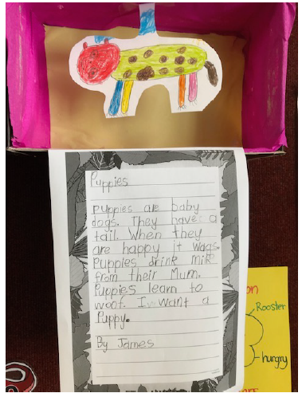
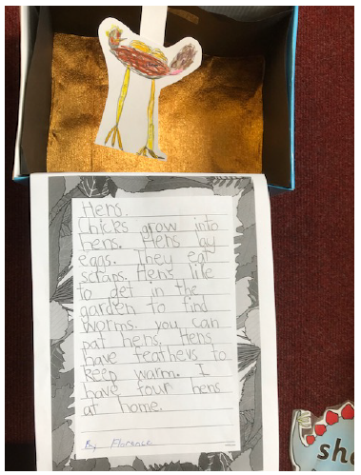
- Here are 2 photos showing some writing the Junior Class have been doing about animals with Miss Flintoff.

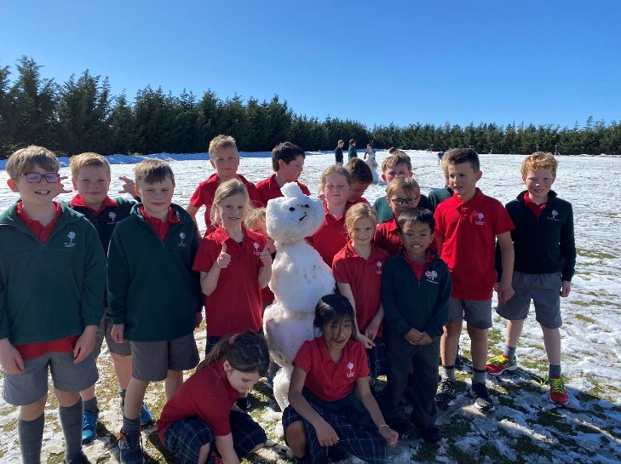
Middle Class News:

Snow day fun! It was impossible to get a photo with everyone looking!

Kia ora! Mrs Mulholland had warned me cross country day was notoriously chilly but a snow day was taking things to the extreme! I would like to say a huge congratulations to all the students who did compete yesterday on a beautiful sunny day, it was worth the wait! They all did so well and I could not be more proud of the effort everyone put in!
This term we are curling, having done our first session last week and going to the rink weekly! The kids are loving it, with some trying it for the first time.
The students (and Teachers) are looking forward to our ‘Fun Run’ in Naseby on Monday and love our new running shirts! Remember it is not too late to find sponsorship. This term is flying by and we are trying to squeeze so much into each week!

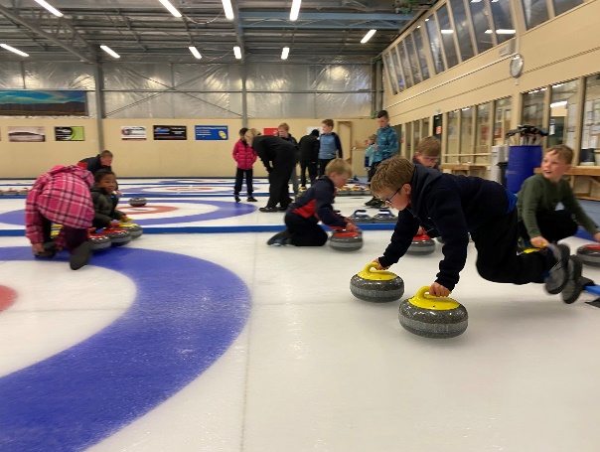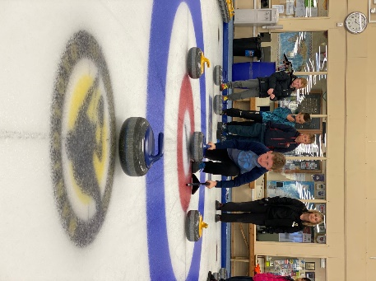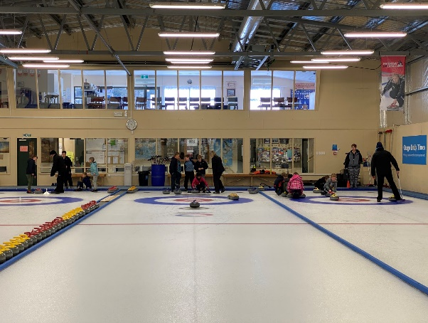
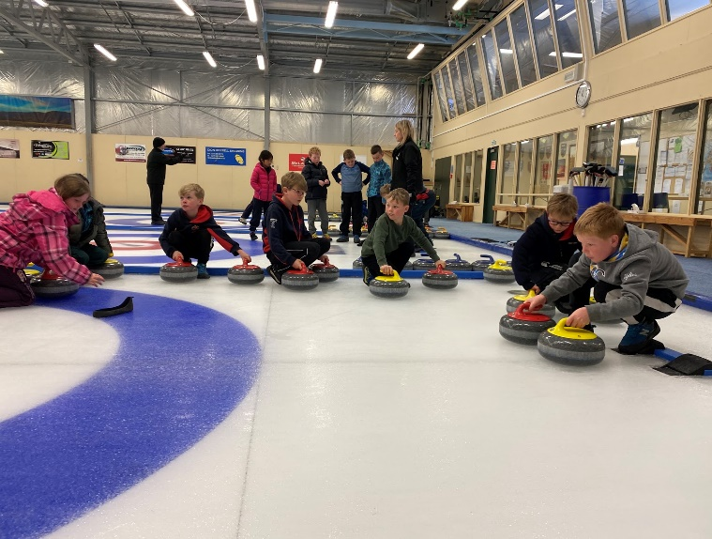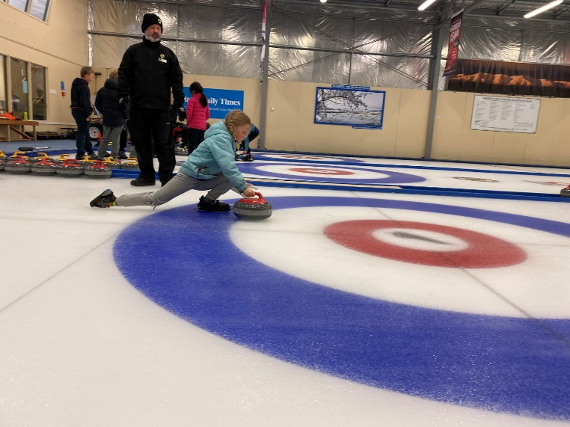

Three weeks ago we started collecting the lunch box waste from the students.
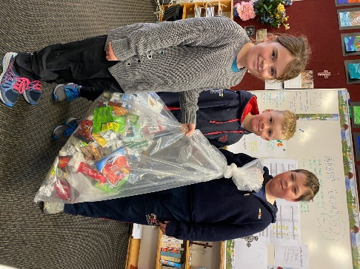
Here is a photo of 1 weeks worth of waste.
As a school we are doing a fantastic job and it is great to see so little waste being created, but we can always do more!

Our goal is to reduce the amount of waste we are producing as a school and one way you can help from home is to limit the amount of plastic waste coming in their lunchboxes.


Reusable containers and beeswax wraps are a great alternative to cling film and plastic bags. For snacks, buy a large bag (of popcorn for example) and then put some into small reusable containers in their lunch box, sealing the large bag with a peg. This means only one single use bag is produced, rather than the 7 + produced with snack sized portions.

Senior Class News:

Refuse, Reduce, Reuse, Rehome, Repurpose,
Recycle and Rot.
Miss Heaney’s wise words of wisdom

School Focus
Miss Heaney has been teaching us about how to care for our environment at the recent School Faith Focus sessions. We were able to turn this into a math learning experience.

Recently the Smart Six math group (year 8’s) have been focusing on Statistics and Data and playing around with graphs. This week at our school Faith Focus our mission was Caring for our Environment. Each classroom had a plastic bag and we put all our lunch box rubbish and wrappings into this bag, on Monday our math group sorted through all the rubbish and put it into categories and made a graph about it as you can see below.
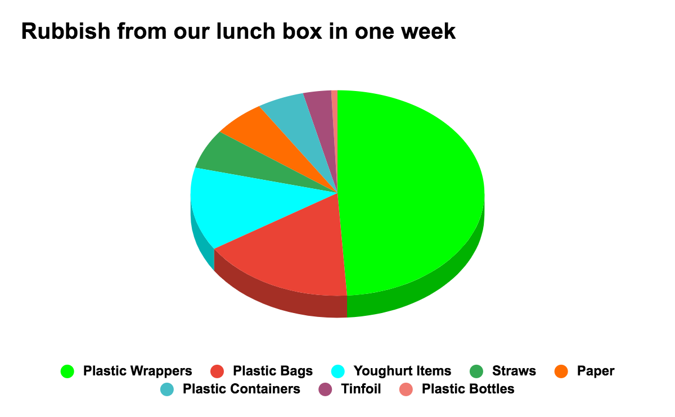
.
Conclusion
- As a school we collected 290 rubbish items over the week.
- The majority of plastic wrappers were made up of mini chip bags and cracker bags at 49.3%.
- Yoghurt items and plastic bags had a similar amount of items.
- We used a similar amount of plastic containers, paper and straws

Our advice for you
- Be aware of the amount of plastic wrappers that are used in our lunch boxes that can’t be reused.
- Consider buying in bulk and divide into reusable containers.
- As a school we should stop using Fonterra straws and use the milo cups instead.
- For our school we should have a limit of how much printing you do for each classroom each week.
- Turn our school food scraps into a compost bin.

Yours Sincerely,
Jake, Alivia, Paxton, Annie, Luke and Grace

Balmoral Book Bonanza
We have our first recipient of the hot chip voucher - congratulations to Phoebe Hore. You are going to love those delicious hot chips that are donated by the Cai family.
Keep working on these activities children as they will be delicious and worth the effort.

Goal Setting
Last Friday the children all brought home a copy of their goals for the remainder of the year. Please read through this with your child and discuss their goals, as they designed these based on their mid year portfolio contents and own reflections. The children's goals are important to them so you might be able to display them somewhere visible so they can check back on them over the remainder of the year. Thank you.

Mathletic Gold Certificates
Congratulations to Ryan Crossan, Georgia Elworthy and Alyssa Janerol for achieving their 20th certificate! I’m so pleased that they have reached this goal. The fantastic work with achieving the Green Bars is paying off and a number of children have joined the property market on Banqer - this is most impressive and a huge learning curve.

Kiwi Sport Curling
We had our first session last Thursday and it was so much fun. The second session was today and we have only two coaching sessions left - Thursday 10th September and Wednesday 16th September. After that we will have our Kiwi Curling Tournament on Tuesday 22nd September, a travel notice will come home closer to the time.

Laura’s Marathon / Food Bank fundraiser
This fun event is being held on Monday 7th of September at the Naseby Swimming Dam. Your child brought home a notice with lots of information regarding this event on Wednesday - hopefully you have seen it!
Key information
- If helping with transport, please turn up on time
- Your child wears their race day t shirt with mufti clothing
- Send your child along with the medication they may need for asthma, hay fever etc
- Pack a lunch box ready for a star athlete :)

We have been generously supported by the following businesses
- Breen Construction
- Southern Wide Real Estate
- Hazlett Contracting
- PGG Wrightsons
- Otago Sports Depot
- Foleys Plumbing
- Maniototo Contracting Ltd
- Maniototo Four Square

Cross Country
How good was it to actually be able to hold an event - although in a slightly different format. The whole class has worked hard towards cross country and you will have felt very proud of your child and their determination.

Altar Serving
Thank you for bringing your children along when it is their turn to altar serve or bell ring at Sunday Mass, we appreciate people doing this and being on time as it affects other children. No one wants to serve on their own as they need the support of each other, as all the children get a bit nervous. If your child can’t be there for their session, help them to organise a swap and make sure you pay the people back a turn, so it is fair for all.

Being active makes us feel good!
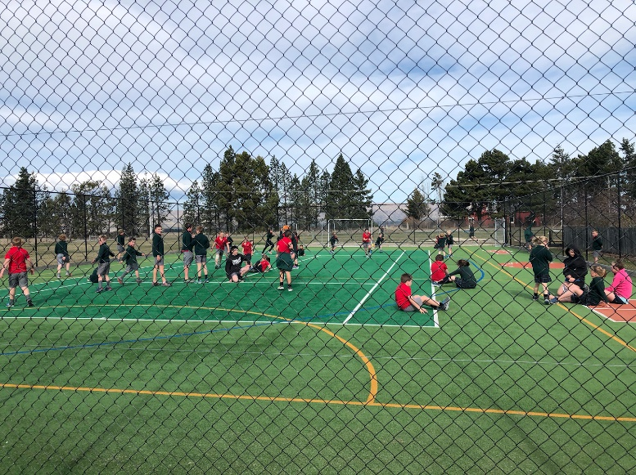
This was the scene on the school turf while I was doing duty on Monday. There were at least 40 children playing a game of tag, ranging right through from our 5 year olds to our 13 year olds. This photo and scene catches our school spirit in action so beautifully.
Meanwhile I was hiding behind the sports shed out of the dreadful wind!!

Upcoming dates for this term
Monday 7th September Laura’s Food Bank Run (children wear the race tee-shirt they have been given)
Thursday 10th September Curling lesson 3
Wednesday 16th September Curling lesson 4
Friday 18th September Otago Cross Country
Tuesday 22nd September Curling Tournament for yrs 6-8

Term costings:
Curling Lessons $10 per child.

Thank you
Geraldine Duncan

Board of Trustees
:
Next meeting Wednesday 9th September at 7.30p.m.

EXCITING NEWS
Check out our new website – www.sjr.school.nz
Please DO NOT use the “Report an Absence” function on the website. Text or call the school cellphone to let the teachers know if your child is not at school.
Included with the website is a App. To download the App, go to the play store/app store and search for Kiwischools connect. Install and then choose St John’s School, Ranfurly from the list. When prompted select subscribe to all.

Notices and Dates:

2020 OPSSA Cross Country Event
Event Status: Updated 1 September 2020
With the hope that we will have moved to Level 1 and that gathering number limits permit, the decision has been made to remove Friday 11 September as a possible date and set Friday 18 September as the only possible date for 2020.
* Proposed event date now Friday 18 September 2020
* There will not be a postponement date for 2020.
* Entries will only open once we are able to confirm the event can proceed.
* We will revise this update as soon as we are able.
Thank you for your patience.

Week 8 | Monday 7th September | Laura’s Food Bank Run
 | Thursday 10th September | Curling – Middle & Senior Classes
Week 9 | Wednesday 16th September | Curling – Middle & Senior Classes
 | Friday 18th September | Otago Cross Country
 | Sunday 20th September | First Holy Communion at 4pm
Week 10 | Tuesday 22nd September | Curling Tournament for Year 6-8
 | Friday 25th September | Last Day of Term 3



